November 2nd, 2022
TOMRA & IKEA highlighted the future of wood recycling in webcast
On October 27th, TOMRA held a live webcast entitled “The future of wood recycling”. During a 45-minute live stream, TOMRA’s wood recycling team and a material expert from IKEA outlined how a circular economy for wood can become a reality and a profitable business case for the panel industry.
The global wood recycling market is dynamic: the industry increasingly recognizes the need to make use of waste wood as it contains valuable recyclable materials that, if properly sorted, can be used as high-quality recyclates to produce new wood-based panels. Today, many wood panel and furniture manufacturers already rely on recycled wood to mitigate price volatility and secure access to sufficient raw materials. The recycling of waste wood significantly influences the transition to a circular economy and helps overcome current challenges.
During TOMRA’s webcast, participants from all over the world listened to presentations from Jose Matas, Segment Manager Wood at TOMRA; Murat Sanli, Wood Sales Engineer at TOMRA; and Jan-Olof Fechter, Material Expert and Technique Engineer at IKEA of Sweden AB. The expert panel provided an overview of the status quo of the market, challenges, and solutions to bring wood full circle.
Matas kicked off the session by explaining current market trends influenced by the energy crisis in Europe, the impacts of climate change, and industry’s increased reliance on recycled content in order to meet its sustainability targets. “The energy crisis is hitting hard on us in Europe. Many households turn to wood as an alternative heating source, therefore further driving up the already record-high demand for wood”, highlighted Matas. “Combined with the general lack of materials on the market, sourcing wood in sufficient volumes and qualities has become increasingly difficult and at all-time high prices.” He added that in order to access material and maintain profitable operations, the panelboard industry has recognized the possibilities a circular treatment for wood offers. If we make use of the massive amounts of waste wood generated annually, and properly collect, sort, and recycle it into individual material fractions, both recyclers and wood-based panel manufacturers reap competitive benefits. Recyclers, on the one hand, are given the means to create individual waste wood fractions, from non-processed wood to MDF, and market it as high-quality secondary materials. Manufacturers, on the other hand, profit from a constant source of input materials, keep operations profitable thanks to a better price point of recycled wood compared to fresh wood, and help ensure the volumes and quantities demanded by the market.
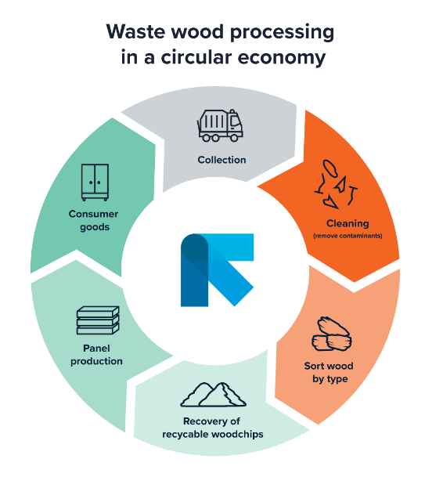

Following Matas, the audience gained informative insights into the manufacturer’s perspective. Jan-Olof Fechter outlined how IKEA incorporates sustainability and recycling into its business and what the company’s long-term goals regarding recycled content look like. “To date, only 1% of furniture is reused, but 99% which is equal to 800,000 metric tons of furniture is recycled. These figures prove that recycling processes are in place and already supporting us on our way to producing greener products. However, there is still untapped potential we must start to access”, explained Fechter. Afterwards, he presented and explained IKEA’s recycled content targets for panelboards and MDF/HDF boards for the future. Whereas in 2020, panelboards were made of 25% recycled content and MDF and HDF panels consisted of virgin material only, in 2025 IKEA targets to increase the amount of recycled content in panelboards to 56% and for MDF/HDF boards to 9%. In a closing slide, Fechter compared the end-of-life process for furniture in general with those of IKEA’s commodities and highlighted the role sensor-based sorting plays in the recovery and production of panelboards and fiberboards with secondary raw materials.
After the first two speakers explained the numerous benefits of a circular economy for wood, Murat Sanli explained how a holistic approach can maximize recycled wood content. “To exploit the full potential of recycled wood, we must concentrate on three pillars: the collection, sorting, and recycling of waste wood”, explained Sanli. Decisive for the final product quality are technology-driven sorting solutions. As outlined by Fechter, manufacturers are striving to become more sustainable and increase recycled content in their panelboards. To do so, they have to use the purest material fractions, such as non-processed wood and MDF. Recovering individual wood fractions requires extensive cleaning and sorting processes because waste wood consists of numerous different materials including contaminants and different types of wood like OSB, MDF, and plywood to coated materials and recyclable non-processed fractions. Using smart technologies throughout the sorting process gives plant operators a three-fold competitive edge: they can recover wood by type as per their requirements, realize high throughputs , and achieve purity levels that cannot be achieved with conventional technology.
In a closing Q&A session, participants had the chance to ask additional questions and showed great interest in the topics covered. For those who could not attend the live session, please visit ….. to watch the recordings.

About TOMRA Recycling
TOMRA Recycling Sorting designs and manufactures sensor-based sorting technologies for the global recycling and waste management industry to transform resource recovery and create value in waste.
The company was the first to develop advanced waste and metals sorting applications use high capacity near infrared (NIR) technology to extract the most value from resources and keep materials in a loop of use and reuse. To date, more than 8,200 systems have been installed in 100 countries worldwide.
TOMRA Recycling Sorting is a division of TOMRA Group. TOMRA was founded on an innovation in 1972 that began with the design, manufacturing and sale of reverse vending machines (RVMs) for automated collection of used beverage containers.
Today, TOMRA is leading the resource revolution to transform how the planet’s resources are obtained, used and reused to enable a world without waste. The company’s other business divisions comprise TOMRA Food, TOMRA Mining and TOMRA Collection.
TOMRA has approximately 100,000 installations in over 80 markets worldwide and had total revenues of ~10.9 billion NOK in 2021. The Group employs ~4,600 globally and is publicly listed on the Oslo Stock Exchange. The company headquarters are in Asker, Norway.
For further information about TOMRA, visit www.tomra.com and follow TOMRA Recycling on Facebook, Instagram, Twitter and on LinkedIn.

Media contacts:
At TOMRA:
Michèle Wiemer
Mail: michele.wiemer@tomra.com
Direct dial: +49 2630 9150 453
Mobile: +49 172 454 930 9

