Allison-Equipped TATRA PHOENIX R46 Showcased During Test Drive Event in Northern Italian Quarry
Allison Transmission, TATRA and Italian TATRA dealer host test drive to showcase the Allison-equipped vehicle’s exceptional performance within extreme conditions.
SLIEDRECHT, The Netherlands, November 24, 2022 - Allison Transmission, a leading designer and manufacturer of conventional and electrified vehicle propulsion solutions for medium and heavy-duty commercial vehicles, along with TATRA and Italian TATRA dealer Zarpellon Veicoli Industriali recently hosted a customer test drive of the TATRA PHOENIX R46 in a quarry in Northern Italy.
The rugged terrain of the quarry outside of Bolzano in Aldino was the ideal setting for a vehicle created for the most extreme applications. The TATRA PHOENIX R46, with a payload of 52 tonnes, DAF cab and 530 horsepower engine, was fitted for the occasion with a tipper body and an Allison fully automatic transmission with torque converter and hydraulic retarder.
TATRA selected the Allison fully automatic transmission for its performance in the most extreme conditions. Thanks to Allison’s Continuous Power Technology™, an Allison Automatic transmits more power to the wheels than other transmissions. Additionally, there is never a power interruption during gear changes and traction is always optimal, which is critical in steep terrain such as quarries.
Directly supporting the PHOENIX R46’s 52 tonnes payload, Allison’s patented torque converter offers great starting power without slipping or backing off. The hydraulic retarder also acts to slow down the vehicle, protecting the brakes and the driveline. With automatic shifting, drivers can concentrate on the job at hand and are more alert and focused with increased control and smoother shifts. This is critically important in applications such as climbing the steep slopes of quarries with large loads.
"TATRA is the third oldest car and commercial vehicle factory in the world. We started producing cars in 1850,” said Veronika Michelovà, Director of Business Development, TATRA. “Today we are famous for our unique chassis concept, which consists of a chassis and oscillating axle shafts that mimic the shape of the ground. This, along with the Allison transmission, is why our vehicles are suitable for the most extreme terrain.“
The combination of the TATRA chassis with independent semi-axles, DAF engine and Allison automatic transmission makes the vehicle an excellent and efficient alternative to common dumpers.
"Customer expectations for this day and for this vehicle were very high, but the vehicle proved to be up to the mark,” said Dario Zarpellon, President of Zarpellon Veicoli Industriali. “The characteristics of the TATRA combined with the great capabilities of the Allison fully automatic transmission make the vehicle unrivalled in the industry."

Throughout the day, several customers from the surrounding area took turns driving the TATRA PHOENIX through the steep climbs and curves of the quarry. Afterwards, customers shared their experiences with the vehicle.
"Many transmissions jerk when changing gears, whereas the Allison transmission’s shifting is smooth. You don't feel fatigue," said Davide Zamberlan, one of the truck drivers at Sipeg, a company specialised in quarry and aggregates works.
"I know TATRA by reputation, but this is the first time I have seen it live and been able to test it. It's a nice truck that performs well on steep terrain," said Luca Michelotti, a dumper driver at Mazzarol Sebastian, a 50-year-old construction company in Laives (Bolzano), Northern Italy.
"Especially on extreme climbs, the Allison transmission shifts like a pleasure, and the vehicle is crazy. You get into the potholes and the wheels follow the ground perfectly thanks to the single axles," said Ilario Mazzarol, who works with his brother Sebastian in the family construction company Mazzarol Sebastian.
The TATRA PHOENIX in detail
Built on the proven TATRA chassis, the TATRA PHOENIX Euro 6 is propelled over the toughest terrain by powerful and efficient, yet environmentally friendly PACCAR engines that meet the strict Euro 6 emission limits.
The unique chassis design does not require an additional subframe to mount tipper bodies, while the installation of other superstructures is simple without the use of compensating mounting parts. Independently suspended axle shafts with air cushioning increase transport speed and thus total transport capacity. Steered axles (front and rear) can be loaded up to 10 tonnes, while non-steered axles have a maximum load of 16 tonnes.
The 6- and 7-speed Allison 4800 transmission is available upon request. The classic clutch is replaced by the torque converter, which multiplies the starting torque. The Allison thus guarantees an uninterrupted transmission of torque to the entire driveline for smooth travel and smooth gear changes, as well as a more relaxed driving experience.
The new cab of the TATRA PHOENIX Euro 6 model, supplied by DAF Trucks, offers more space and comfort.
TATRA’s heavy-duty trucks are renowned for their ability to go anywhere in the toughest terrain under extreme weather conditions, high reliability and excellent utility properties. The TATRA withstands both frost and high desert temperatures.
The excellent driving performance and numerous technical and design innovations of the TATRA vehicles have been verified in long-duration competitions over many years. TATRA crews have competed successfully in the famous Dakar Rally, a competition where the Allison-equipped vehicles finished in the top 10 this year.

To learn more and watch the event video, please visit:
Allison-equipped Tatra Phoenix in Italian Quarry

About Alison Transmission
Allison Transmission (NYSE: ALSN) is a leading designer and manufacturer of vehicle propulsion solutions for commercial and defense vehicles and the largest global manufacturer of medium- and heavy-duty fully automatic transmissions that Improve the Way the World Works. Allison products are used in a wide variety of applications, including on-highway trucks (distribution, refuse, construction, fire and emergency), buses (school, transit and coach), motorhomes, off-highway vehicles and equipment (energy, mining and construction applications) and defense vehicles (tactical wheeled and tracked). Founded in 1915, the company is headquartered in Indianapolis, Indiana, USA. With a presence in more than 150 countries, Allison has regional headquarters in the Netherlands, China and Brazil, manufacturing facilities in the USA, Hungary and India, as well as global engineering resources, including electrification engineering centers in Indianapolis, Indiana, Auburn Hills, Michigan and London in the United Kingdom. Allison also has more than 1,400 independent distributor and dealer locations worldwide. For more information, visit allisontransmission.com.

Contacts
Susanna Laino Eric Black
Alarcon & Harris Italy Allison Transmission
susanna.laino@alarconyharris.com Global External Communications
Tel: +39 (0)722- 331928 eric.black@allisontransmission.com
Via Polidoro Virgili 7 Tel: +1(317)242-3515
61033 Fermignano (PU) One Allison Way
Indianapolis, Indiana, United States

Images
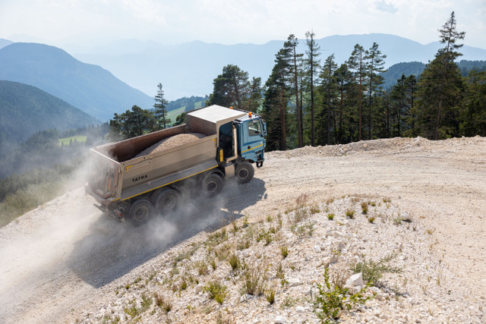  © Allison Transmission | The vertical quarry in Aldino (Bolzano) was the ideal setting for test driving the TATRA PHOENIX R46, a vehicle designed for extreme terrain. The vehicle, with a payload of 52 tonnes, DAF cab and 530 hp engine, was fitted with a tipper body and an Allison fully automatic transmission with torque converter and hydraulic retarder.
© Allison Transmission | Luca Michelotti driving the Allison-equipped TATRA PHOENIX during the recent test drive event, where several customers took turns driving the TATRA PHOENIX through the quarry’s steep climbs and curves.
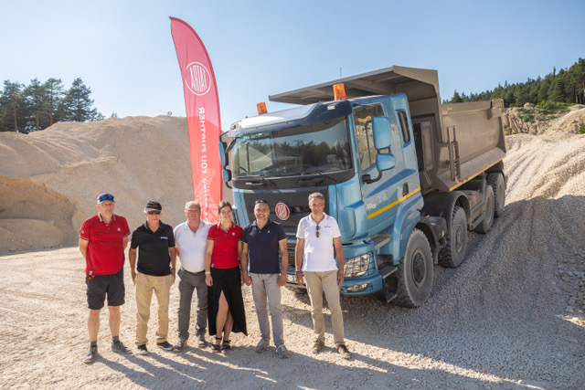  © Allison Transmission | Event hosts from Allison Transmission, TATRA and Zarpellon Veicoli Industriali gather at the recent test drive event, including Sergio Camolese, Director European Market Development of Allison Transmission (second from left) next to Dario Zarpellon, President of Zarpellon Veicoli Industriali (center) and Veronika Michelovà, Director of Business Development, TATRA.
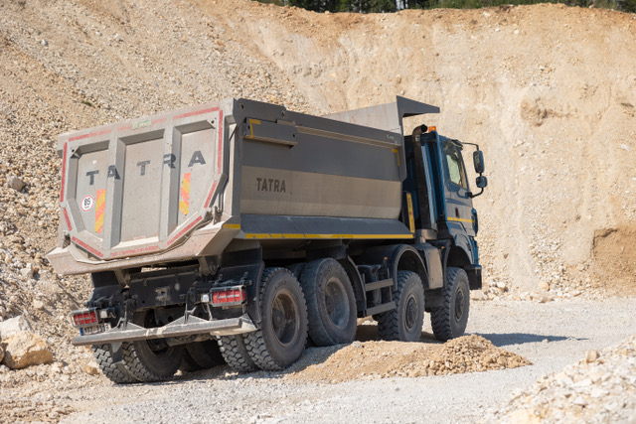  © Allison Transmission | “We are famous for our unique chassis concept, which consists of a chassis and oscillating semi-axles that mimic the shape of the ground,” said Veronika Michelovà, Director of Business Development, TATRA.
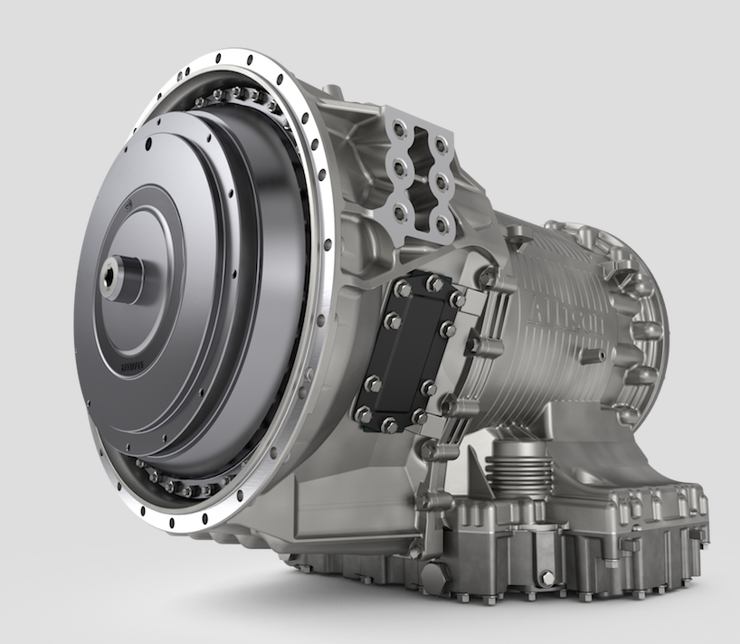  © Allison Transmission | Directly supporting the PHOENIX R46’s 52 tonnes payload, Allison’s patented torque converter offers great starting power without slipping or backing off. The hydraulic retarder also acts to slow down the vehicle, protecting the brakes and driveline.

