Allison Transmission to Present New Fully Electric Axle
for Fire and Rescue Vehicles at Interschutz 2022

Allison Transmission and Emergency One to exhibit the first fire engine with the new eGen Power® electric axle. Allison to also display the new TerraTran™ fully automatic transmission for airport fire and rescue vehicles.

SLIEDRECHT, The Netherlands, June 2, 2022 – Allison Transmission, a leading designer and manufacturer of conventional and electrified vehicle propulsion solutions for medium and heavy-duty commercial vehicles, is introducing its new electric axle, Allison eGen Power®, for fire and rescue vehicles at Interschutz 2022 (June 20 – 25, Hanover, Hall 27, Stand H 38). Emergency One, a British manufacturer of fire and rescue vehicles, has integrated the eGen Power 100D into the new E1 EV0™ platform on a MAN TGM chassis and is presenting the vehicle for the first time at Interschutz (outdoor area, stand R54) in cooperation with Allison.

eGen Power® is a bolt-in solution compatible with the current vehicle frame. It features two fully integrated electric motors, a two-speed gearbox, oil cooler and pumps. The twin-engine 100D version has a continuous output of 454 kilowatts and a peak output power of 652 kilowatts. The eGen Power 100D axle is one of the most powerful electric axle systems on the market. It was designed for good starting and climbing capabilities, high speed and high efficiency. This allows fire and rescue vehicles to offer unsurpassed performance and reliability, high acceleration and excellent maneuverability. Allison also offers the eGen Power 130D, a variant of the 100D, specifically designed for the European and Asia Pacific markets, where many commercial vehicles require a heavier 13 tonne gross axle weight rating

The TerraTran™ transmission is a variant of the proven Allison 4000 Series™ on-highway transmission and is purpose built for the extreme demands of airport fire engines. TerraTran offers a maximum power capability of up to 800 horsepower, and torque capability up to 3200 newton meters. The transmission also features seven forward and two reverse gears. TerraTran offers the proven reliability and durability of the Allison 4000 Series transmissions, but with increased horsepower, torque and gross vehicle weight (GVW) capability, while also adding fast reverse capability.

Visitors to the Allison booth at Interschutz 2022 are invited to explore the eGen Power axle and Allison’s fully automatic transmissions via an interactive augmented reality experience where they will be able to view the products 360° and view internal components. Allison technical experts will be available to provide information on the full range of products and technologies offered by the company and to discuss the transition to electrification.

Invitation to editors
Allison Transmission cordially invites editors to a technical update at Interschutz
on Tuesday, June 21, 2022 at 2:00 p.m. (Hall 27, Stand H38)

Topics include:
• Launch of first electric vehicle equipped with eGenPower®:
Emergency-One electric EV0™ fire appliance built on MAN chassis (outside area, Stand R54)
• Allison's electrification strategy, introducing the new electric axle for trucks
• New TerraTran transmission for ARFF applications
(Subject to change)

Please let us know if you will attend the event.

About Alison Transmission
Allison Transmission (NYSE: ALSN) is a leading designer and manufacturer of vehicle propulsion solutions for commercial and defense vehicles and the largest global manufacturer of medium- and heavy-duty fully automatic transmissions that Improve the Way the World Works. Allison products are used in a wide variety of applications, including on-highway trucks (distribution, refuse, construction, fire and emergency), buses (school, transit and coach), motorhomes, off-highway vehicles and equipment (energy, mining and construction applications) and defense vehicles (tactical wheeled and tracked). Founded in 1915, the company is headquartered in Indianapolis, Indiana, USA. With a presence in more than 150 countries, Allison has regional headquarters in the Netherlands, China and Brazil, manufacturing facilities in the USA, Hungary and India, as well as global engineering resources, including electrification engineering centers in Indianapolis, Indiana, Auburn Hills, Michigan and London in the United Kingdom. Allison also has more than 1,400 independent distributor and dealer locations worldwide. For more information, visit allisontransmission.com.

Contacts
Susanne Megill Eric Black
geldermannKommunikation Allison Transmission
susanne.megill@geldermannkommunikation.de Global External Communications
Tel: +49 (0)2802- 948 40 88 eric.black@allisontransmission.com
Holländer Str. 6 Tel: +1(317)242-3515
D-46519 Alpen One Allison Way
Indianapolis, Indiana, United States

Images (for editorial use only)

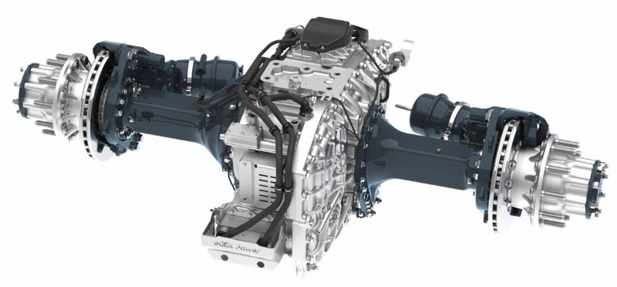  © Allison Transmission | Allison eGen Power® is a bolt-in solution compatible with the current vehicle frame and well suited to most OEM vehicle assembly processes. It features fully integrated electric motors, a two-speed gearbox, oil cooler and pumps.
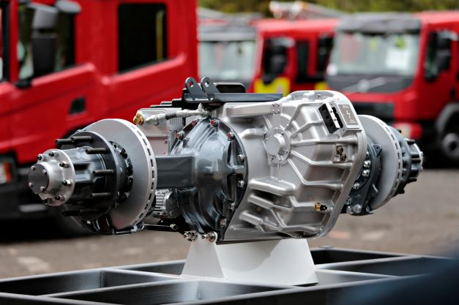  © Allison Transmission | Emergency One, a British manufacturer of fire and rescue vehicles, has integrated the eGenPower 100D into the new E1 EV0™ platform on MAN TGM chassis and is presenting the vehicle for the first time at Interschutz (outdoor area, stand R54) in cooperation with Allison.
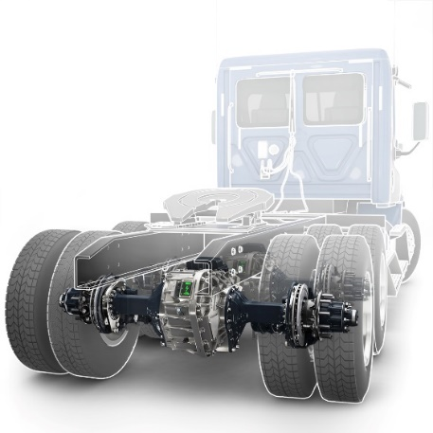  © Allison Transmission | The eGen Power® 100D axle is one of the most powerful electric axle systems on the market. The twin-engine 100D version has a continuous output of 454 kilowatts and a peak output power of 652 kilowatts.
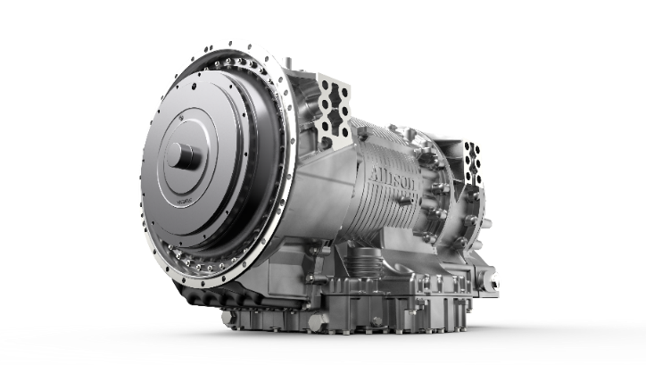  © Allison Transmission | TerraTran™ offers a maximum power capability of up to 800 horsepower, and torque capability up to 3200 newton meters. The transmission also features seven forward and two reverse gears.

