JOHANN KRAUT FARMING OPERATION INVESTS IN TOMRA 3A OPTICAL SORTER
TO ENSURE TOP QUALITY POTATOES FOR FRENCH FRIES
The potato specialist benefits from the system's high sorting performance, reliable detection of foreign materials, and easy handling and maintenance.
Leuven, Belgium, 1 March 2022 – German business Johann Kraut Landwirtschaft is a real potato specialist: the family-run 90-hectare (220-acre) at Bergkirchen, Bavaria, is now in the third generation and has been growing Potatoes for more than 50 years. For almost two decades now, the company has focused on supplying the food industry, mainly growing Potatoes to produce French Fries.
Three different varieties of potato meet the special requirements of French Fries. Johann Kraut explains: "Manufacturers primarily prefer varieties that yield especially large Potatoes. Potatoes must contain a certain starch content to be suitable for French fry production. We mainly grow the Fontane variety here and supply a large regional buyer of Potatoes for French fry production."
TOMRA 3A reliably removes foreign materials
Concentrating on the French fry industry has opened up a new, rapidly growing market for the farm. To consistently supply customers with top quality, the Potatoes are sorted after harvesting to remove stones and dirt, then stored with constant ventilation at 8°C. Prolonging storage time and preventing the Potatoes from being damaged is possible only by first removing unwanted materials, such as dirt clods, stones and other foreign objects, as well as green potatoes. For this purpose, the company has been using the TOMRA 3A 1200 sorter (with a 1200mm-wide infeed conveyor) since 2021, making the work much easier. This machine is positioned at the entrance to the potato warehouse, where the Potatoes are sorted directly before going into storage.
Andreas Kraut, junior manager at Johann Kraut Landwirtschaft, says the farm's demands on the sorting system are high: "Due to our specific soils, a high proportion of foreign materials are harvested with the Potatoes, so robustness and durability are essential. Other important requirements included a user-friendly design and high safety standards. We decided to invest in the TOMRA 3A as it fulfills all of these requirements and was recommended to us by another user in the region. "
The TOMRA 3A is equipped with multi-spectral NIR (near-infrared) sensors. After the Potatoes are fed to the machine by an integrated infeed belt, they are scanned in flight to sort out stones, dirt clods, and other foreign objects from the harvest in an intelligent, finger-based ejection process that minimizes loss of good produce. The Potatoes continue their natural, free fall onto a trampoline belt that prevents them from being damaged.
Well-equipped to meet increasing demand
This investment by the family-run farm has paid off. Optical sorting has substantially reduced the workload during harvest time, and the result – cleaner Potatoes and a higher daily yield – is convincing.
Andreas Kraut said: "We used the TOMRA 3A for the first time in the 2021 harvest season. The sorting capacity of the machine depends on the soil, among other things. With good conditions, it is possible to sort 40 tons per hour. Under demanding conditions, the high-capacity sorter saved us a great deal of time and was instrumental in helping us meet our tight schedules.
"Also, the relatively large distance between the camera and the ejection process minimized the need for cleaning so that the sorter was continuously operational. During pauses between sorting, briefly removing dust from the lens protector with an air pistol, and wiping it over with a cloth in the evening, was completely sufficient for optimal sorting results."
While the sorter has already proved to be a wise investment, Andreas believes it will become even more important to the business: "We assume that the demand for potatoes will increase in the future, especially when more large-scale dining can take place once the pandemic has subsided."

About TOMRA Food
TOMRA Food designs and manufactures sensor-based sorting machines and integrated post-harvest solutions for the food industry. We innovate the world's most advanced analytical technology and apply it to grading, sorting, and peeling.
Over 12,800 units are installed at food growers, packers, and processors worldwide for confectionery, fruit, dried fruit, grains and seeds, potato products, proteins, nuts, and vegetables.
The company's mission is to enable its customers to improve returns, gain operational efficiencies, and ensure a safe food supply via innovative, useable technologies. To achieve this, TOMRA Food operates centers of excellence, regional offices, and manufacturing locations within Europe, the United States, South America, Asia, Africa, and Australasia.
TOMRA Food is a member of the TOMRA Group that was founded on an innovation in 1972 that began with the design, manufacturing, and sale of reverse vending machines (RVMs) for automated collection of used beverage containers. Today TOMRA provides technology-led solutions that enable the circular economy with advanced collection and sorting systems that optimize resource recovery and minimize waste in the food, recycling and, mining industries and is committed to building a more sustainable future.
TOMRA has 100,000 installations in over 80 markets worldwide and had total revenues of 9.9 billion NOK in 2020. The Group employs 4,300 globally and is publicly listed on the Oslo Stock Exchange (OSE: TOM). For further information about TOMRA, please see www.tomra.com.

Media Contacts:
Nuria Martí, Alarcon & Harris PR  Avda. Ramón y Cajal, 27  28016 Madrid, Spain  T: +34 91 415 30 20  E: nmarti@alarconyharris.com  W: www.alarconyharris.com | Marijke Bellemans  Marketing Communications Manager TOMRA Food  Research Park Haasrode 1622 – Romeinse straat 20  3001 Leuven, Belgium  M: +32 (0)476 74 19 18  E: marijke.bellemans@tomra.com  W: www.tomra.com/food
Photos:

Potato warehouse

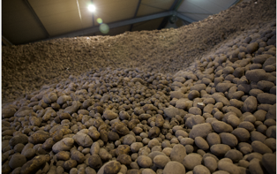

Andreas and Johann Kraut demonstrate the benefits of the TOMRA 3A

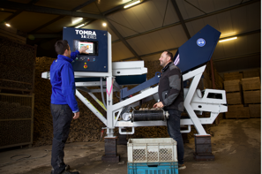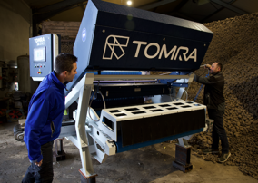

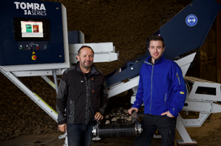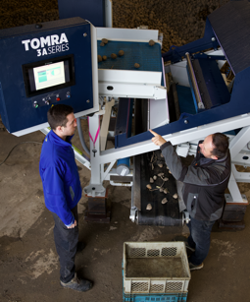
Andreas and Johann Kraut enjoy a successful harvest thanks to their recent purchase of the TOMRA 3A.
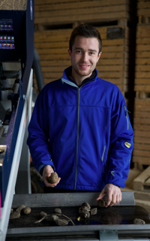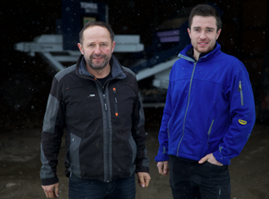

The TOMRA 3A potato sorter from TOMRA Food

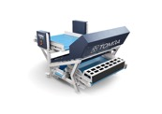
(Photo: TOMRA Food)

