Offenbach am Main, January 2022

Falken on track for a carbon neutral future

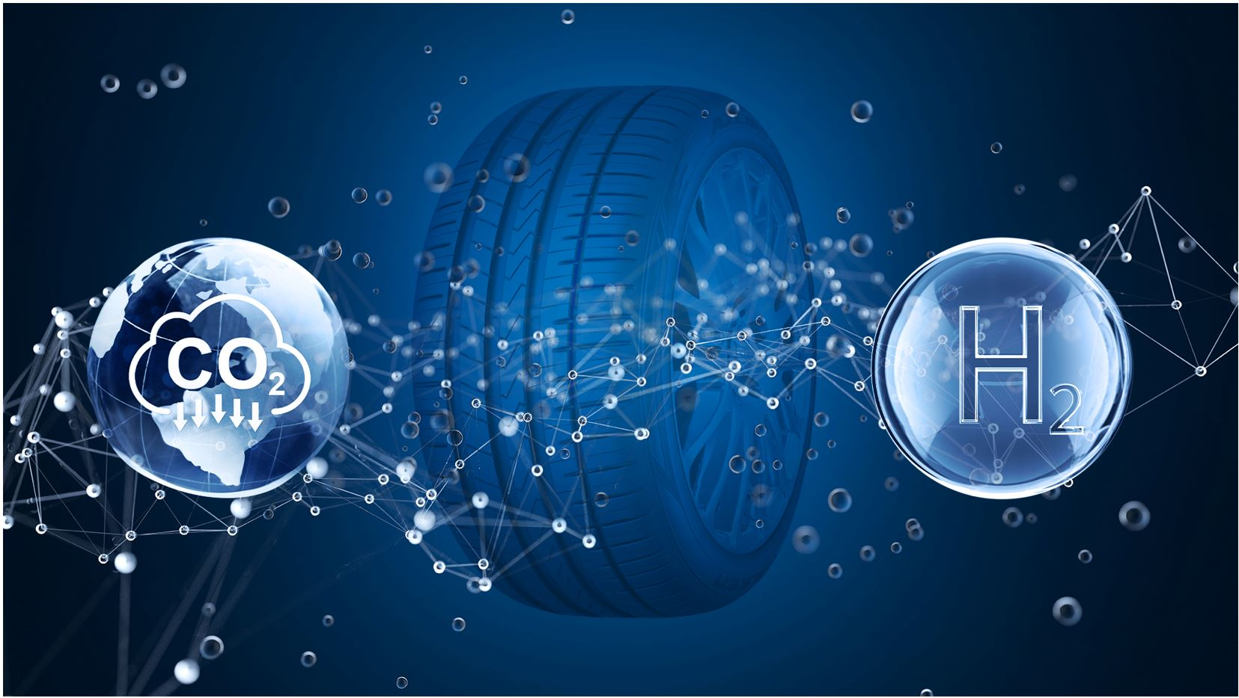

Falken’s push to reduce the carbon footprint of its tyres is progressing apace with the brand currently trialling the use of hydrogen in one of its major Japanese plants. Significant resources are being put towards this change in its methodology to help meet its target to become carbon neutral by 2050. Progress in recent months means Falken and its parent company, Sumitomo Rubber Industries (SRI), remain confident that a carbon neutral future is on track.

High-temperature energy in the form of steam is essential in tyre production. Due to various technical limitations, it is difficult to generate the required amount of heat using electrical energy. This is where hydrogen comes in as a promising new energy source: SRI uses hydrogen to produce its tyres without CO2 emissions. The pilot project, supported by the New Energy and Industrial Technology Development Organisation (NEDO), will demonstrate the potential of hydrogen in tyre production. Currently, the hydrogen tanks are being tested at SRI’s Shirakawa plant in central Japan, and the hydrogen required also comes from one of SRI’s plants. If the use of the new energy proves successful, the company plans to use it worldwide from 2023.

“There are several initiatives that we, alongside other leading tyre makers and car manufacturers, have signed up to in order to achieve ambitious targets,” explains Dr. Bernd Löwenhaupt, managing director, Sumitomo Rubber Europe. “Reducing the carbon footprint of our products is vital for our future, so we remain fully focused on using sustainable materials, extending the life of our tyre range and manufacturing tyres using environmentally friendly processes. The use of hydrogen boilers is a major step in the right direction for us, which we hope will revolutionise the way we produce our tyres in the coming years.”

Falken has been committed to become environmentally friendly for decades. Back in 2008 it presented a tyre made of 97 per cent fossil resource-free material, ahead of producing the world’s first fossil-fuel-free tyre in 2013. Three years later, it joined the Sustainable Natural Rubber Initiative (SNR-i), established by the International Rubber Study Group (IRSG) and later became a founding member of the Global Platform for Sustainable Natural Rubber (GPSNR).

Alongside its changes in manufacturing, Falken’s SMART TYRE initiative, which investigates every element of a tyre, is another key aspect to Falken’s roadmap to carbon neutrality. Beyond progress in materials and performance, SMART TYRE also focuses on tyre life, sustainability, and manufacturing, with the goal of introducing a 100 per cent sustainable tyre to the marketplace by 2050.

To achieve this, Falken is increasing the percentage of biomass in its tyres; for example, rapeseed flowers, pine tree oil, corn and recycled materials. Currently, Falken tyres are approximately 25 per cent biomass. On the road to a fully sustainable tyre, Falken aims to increase biomass proportions to 30 per cent and recycled material to 10 per cent by 2030. Additional sustainability-focused changes are also being implemented, including the removal of plastic from tyre labels.

Falken also aims to extend the life of its tyres with SMART TYRE. Tyre longevity is a key pillar of sustainability, which is why SRI has become one of the first companies to use the world’s fastest supercomputer, Fugaku, as part of its R&D programmes. Fugaku can perform 442 quadrillion calculations a second and is aiding the development of Performance Sustaining Technology (PST), which looks to prevent the decline in tyre performance that occurs over time due to wear and tear. It does this by accurately simulating molecular behaviour and actual chemical changes.

Falken Tyre Europe
Falken Tyre Europe GmbH is the European affiliate of Japanese tyre manufacturer Sumitomo Rubber Industries Ltd. (SRI); with more than 39,298 employees, it is the fifth largest tyre manufacturer worldwide. In 2001 and 2014 SRI was selected to appear in the Thomson Reuters ‘Top 100 Global Innovators’ list of the world’s most pioneering companies. From its location in Offenbach, Main, the company markets and sells a complete tyre portfolio for passenger cars, light trucks, trucks, pick-ups and SUVs as original equipment and for the entire European retrofitting market. All Falken factories comply with the ISO 9001, IATF 16949 as well as environmental standard ISO14001. Developed and tested in the world’s most demanding racing series, Falken tyres provide maximum driving pleasure. The Falken brand is involved in exciting and high technology platforms such as motorsport with two Porsche 911 GT3 R race cars and at the BORUSSIA PARK stadium, which is the stadium of Bundesliga club Borussia Mönchengladbach.
For more information visit www.falkentyre.com
Company Media Contact:
Falken Tyre Europe GmbH
Kerstin Schneider, Tel.: + 49 69 247 5252 676, Mobil +49 151 10846870
Fax: +49 69 247 5252 89676
E-Mail: pr@falkentyre.com

