Allison Transmission Introduces xFE Transmissions for Medium-Duty Trucks
Fuel-saving, emissions-reducing transmission, proven worldwide on buses, now also offers truck operators an affordable stepping stone on the path towards electrification
SLIEDRECHT, The Netherlands – June 2nd 2021 – Allison Transmission has introduced two new versions of its xFE fully automatic transmission for use in medium-duty trucks in the EMEA region. Available now, the 3000 xFE™ and 3200 xFE™ models are designed for engines producing up to 370 horsepower and 1695 Nm (dependent on the application), and gross vehicle weight up to 28.5 tons.
Compared to the standard 3000 and 3200 Series transmissions, the new 3000 xFE and 3200 xFE can reduce CO2 emissions and fuel consumption by up to 3.7 percent. The greatest gains are made at speeds below 20 mph (32 kph), depending on axle ratio, and above 45 mph (72 kph).
Gradeability, the fully-loaded vehicle’s ability to climb an incline at a steady speed without needing to downshift and work the engine harder, also improves under 30mph (48 kph). These characteristics make the new transmissions particularly well-suited to slow-speed urban applications and stop-start duty cycles such as refuse collection.
“Truck fleet operators everywhere are under legislative pressure to reduce emissions, and of course all fleets would like to reduce their fuel costs. These new xFE transmissions could be a critical tool in helping OEMs and fleets make a 15 percent CO2 emission reduction by 2025 and 30 percent by 2030, as required by EU CO2 emissions standards for heavy-duty vehicles. Doing much more with today’s efficient diesel technology is an affordable and environmentally-responsible stepping stone on the path towards electrification and other non-fossil fuel propulsion systems for which we also have suitable propulsion solutions, ” said Sjoerd Vos, Allison Transmission Director of EMEA Marketing.
Allison’s xFE transmission is proven over millions of miles in service on thousands of transit and city buses around the world. xFE primarily increases fuel efficiency by locking up at lower speeds, enabling the engine to spend more time in higher ranges and at lower revolutions per minute (rpm). In addition to reducing fuel consumption and emissions, this also reduces the powerpack’s heat rejection, further improving performance.
The new 3000 xFE and 3200 xFE take this successful strategy further by locking up in first gear rather than second, and by making the final overdrives deeper, improving the spread of gear ratios from 5.37 to 5.91. These changes have been made without any need to alter the external form, fitting, servicing schedule, or weight of the 3000 Series™.
Both the 3000 xFE and 3200 xFE models are offered with or without a retarder, and both are equipped with Allison’s FuelSense® 2.0 package of smart controls to precisely balance fuel economy and performance. FuelSense 2.0 features the following:
- Neutral at Stop to reduce or eliminate the load on the engine when the vehicle is stopped.
- Acceleration Rate Management to mitigate aggressive driving by automatically controlling engine torque.
- DynActive® Shifting’s intelligent algorithm to initiate subtle alterations in gear shift points according to factors such as vehicle weight, road gradient, stop-start frequency, and throttle use.
The efficiency of Allison’s xFE transmission can add up, across a vehicle fleet, to environmental benefits of surprising significance. Allison has provided an example simulation of the impact, using the European Commission-developed Vehicle Energy Consumption Calculator Tool (VECTO), for a typical refuse truck and duty cycle. Based on the 3.7 percent fuel and CO2 savings, the results showed that on one truck alone, the €533 fuel-cost saving during a typical 12,500-mile year is equivalent to eliminating the CO2 emissions of 3.8 barrels of oil, 65 bags of waste recycled rather than landfilled, or 195,600 smart phone charges. As clean-air regulations around the world progressively reduce permissible CO2 emissions, such savings will be not only desirable, but necessary.
Various bus OEMs around the world have selected Allison’s xFE transmissions since their launch in 2015. In addition, the xFE has already been developed for some truck applications. The Hyundai “Mighty” Light Duty Truck is equipped with an Allison 1000 xFE transmission for use in pick-up and delivery, specialty, refuse and fire applications in the domestic Korean market and for export to Australia. In 2020, Allison launched its 3414 Regional Haul Series™ fully automatic transmission, based on xFE technology, for North America.

About Allison Transmission
Allison Transmission (NYSE: ALSN) is the world’s largest manufacturer of fully automatic transmissions for medium- and heavy-duty commercial vehicles and medium- and heavy-tactical U.S. defense vehicles, as well as a supplier of commercial vehicle propulsion solutions, including electric hybrid and fully electric propulsion systems. Allison products are used in a wide variety of applications, including on-highway trucks (distribution, refuse, construction, fire and emergency), buses (school, transit and coach), motorhomes, off-highway vehicles and equipment (energy, mining and construction applications) and defense vehicles (wheeled and tracked). Founded in 1915, the company is headquartered in Indianapolis, Indiana, USA. With a market presence in more than 80 countries, Allison has regional headquarters in the Netherlands, China and Brazil with manufacturing facilities in the U.S., Hungary and India. Allison also has approximately 1,500 independent distributor and dealer locations worldwide. For more information, visit allisontransmission.com.
Contacts
Claire Dumbreck  Propel Technology  claire@propel-technology.com  +44 (0)1295 770868  Unit 4, Manor Farm Offices  Northend Road, Fenny Compton  Warwickshire, UK | Miranda Jansen  Allison Transmission Europe  Marketing Communications  miranda.jansen@allisontransmission.com  +31 (0) 78 6422 174  Baanhoek 118  Sliedrecht, The Netherlands

Images (for editorial purpose only)
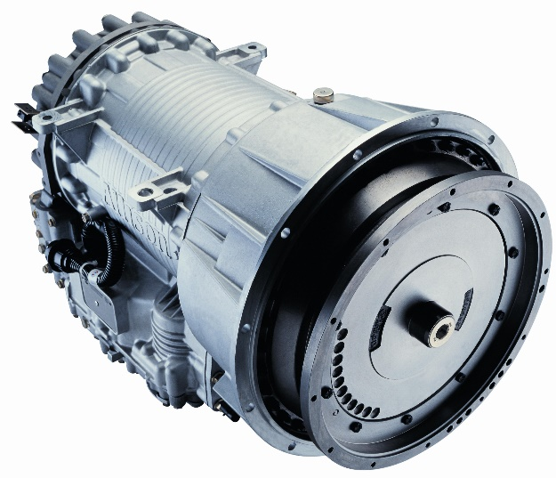  © Allison Transmission  https://cdn2.webdamdb.com/220th_sm_CuR2aJlZMQyj.jpg?1591115279 | Allison Transmission has introduced two new versions of its xFE fully automatic transmission for use in medium-duty trucks in the EMEA region. Available now, the 3000 xFE™ and 3200 xFE™ models are designed for engines producing up to 370 horsepower and 1695 Nm (dependent on the application), and gross vehicle weight up to 28.5 tons.

