Allison Transmission Extends Warranty for Construction Vehicles
Generous new 2021 warranty offer in the EMEA region is part of an initiative to raise awareness of the advantages of fully automatic transmissions over automated manual transmissions.
SLIEDRECHT, The Netherlands, February xx 2020 – Allison Transmission, the world’s largest manufacturer of fully automatic transmissions for medium- and heavy-duty commercial vehicles, has launched a new promotion for the construction industry. Beginning in January 2021, all new on-highway construction vehicles ordered and delivered between January 1st and December 31st, 2021 with Allison’s 4000 Series™ transmission will be entitled to a five-year warranty, extending the standard two-year warranty, free of charge. This offer is being made across the entire Europe, Middle East and Africa (EMEA) region and is valid for construction trucks like tipper, skip and hook loaders and concrete mixers only. Interested end users can contact an Allison Transmission representative to confirm if vehicles are eligible for this promotional program.
“By extending the warranty on the Allison 4000 Series™ transmission to five years, we are reflecting the confidence held by our construction industry customers in the durability, reliability and performance of our products,” said Sergio Camolese, Director of Market Development, Allison Transmission Europe “Allison fully automatic transmissions are proven and insisted upon in the most severe construction applications where their benefits over automated manual transmissions (AMTs) are well understood by construction OEMs and operators. We aim to improve awareness of the benefits of Allison Automatics among the EMEA on-highway construction vehicle sector.”
Allison transmissions offer a range of performance advantages in severe operation. These include improved maneuverability to creep in soft soil and navigate tight spaces, better control on steep grades, superior startability and faster acceleration, resulting in higher average speeds and increased productivity, enhanced fuel economy, less servicing downtime and lower operational costs.
Although the manual clutch pedal is eradicated in AMTs, the launch nevertheless requires a mechanical clutch, a component which needs regular maintenance and eventually replacement. Allison fully automatic transmissions use a patented torque converter, rather than a clutch, and require only periodic fluid and filter changes to maintain peak performance.
Allison’s Continuous Power Technology™ ensures uninterrupted delivery of engine power to the wheels without any power loss during gear shifts. Continuous Power Technology also enables precise control and superior crawling capability – useful on the loose, soft, or rugged ground often found at construction sites.
Allison’s Extended Transmission Coverage begins at the end of the Standard Limited Warranty period. Use of Allison Approved TES 668™/TES 295® transmission fluid and Genuine Allison Filters are required. All Allison transmissions with Extended Transmission Coverage have 100 percent parts and labor coverage with no mileage limitations.

About Alison Transmission
Allison Transmission (NYSE: ALSN) is the world’s largest manufacturer of fully automatic transmissions for medium- and heavy-duty commercial vehicles and medium- and heavy-tactical U.S. defense vehicles, as well as a supplier of commercial vehicle propulsion solutions, including electric hybrid and fully electric propulsion systems. Allison products are used in a wide variety of applications, including on-highway trucks (distribution, refuse, construction, fire and emergency), buses (school, transit and coach), motorhomes, off-highway vehicles and equipment (energy, mining and construction applications) and defense vehicles (wheeled and tracked). Founded in 1915, the company is headquartered in Indianapolis, Indiana, USA. With a market presence in more than 80 countries, Allison has regional headquarters in the Netherlands, China and Brazil with manufacturing facilities in the U.S., Hungary and India. Allison also has approximately 1,500 independent distributor and dealer locations worldwide. For more information, visit allisontransmission.com.

Media Contacts

Claire Dumbreck  Propel Technology  claire@propel-technology.com  +44 (0)7768 773857 | Miranda Jansen  Allison Transmission Europe  miranda.jansen@allisontransmission.com +31 (0) 78 6422 174

Images (for editorial purpose only)
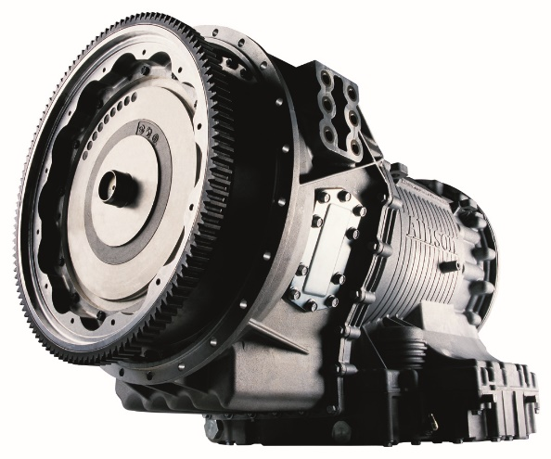 | Starting January 2021, all new on-highway construction vehicles ordered and delivered between January 1st and December 31st, 2021 with Allison’s 4000 Series™ transmission will be entitled to a five-year warranty, extending the standard two-year warranty, free of charge.

