Vizcaya upgrades Firefighting and Rescue fleet with 15 Allison-equipped vehicles

The Vizcaya Provincial Council has renewed its firefighting fleet through the acquisition of 15 state-of-the-art vehicles fitted with Allison fully automatic transmissions. These vehicles will be deployed at the Urioste, Basauri, Artaza, Iurreta, Gernika, Zalla and Derio fire stations.

Vizcaya, Spain, March 2021 – The acquisition of the 15 new vehicles by the Vizcaya Provincial Council means that almost 25% of the existing fleet will be replaced. The new trucks will bolster the province’s Fire Prevention, Firefighting and Rescue Service by enhancing efficiency and improving rapid response capabilities. The new vehicles, acquired through investment of 7 million euros, include 6 heavy-duty urban fire trucks, 3 heavy-duty large-tank pumpers, 3 first-response trucks and 3 automatic turntable ladders, all fitted with Allison automatic transmissions.

Galician company VEICAR built the bodywork for nine of these vehicles and ensured that each of them is correctly adapted to meet the needs of firefighting teams. VEICAR has 40 years of experience in fire station management, the commercialization of fire fighting vehicles and equipment, and professional vehicle transformation.

VEICAR delivered 6 heavy-duty urban fire trucks to the Vizcaya Provincial Council. The bodywork is mounted on a SCANIA P 410 B chassis with 4x4 traction and Allison 4000R SeriesTM transmissions. These trucks have water and foam tank capacities of 4,200 liters and 200 liters respectively. They are equipped with roof boxes that can be accessed from the ground, making it unnecessary to enter the truck to access tools, an LED lighting mast to provide additional lighting if required and a monitor that provides a joystick-controlled flow rate of 4,000 liters per minute from the pump cabinet. The scope of supply included 3 large-tank pumpers, also with bodywork mounted on SCANIA P 410 B chassis. These vehicles, which have the same features as the trucks described above, are also fitted with Allison 4000R SeriesTM transmissions. They have larger water and foam tank capacities of 9,000 and 300 liters respectively.

Like many other vehicle bodybuilders, VEICAR has full confidence in the benefits of Allison fully automatic transmissions and has worked in close cooperation with Allison since 2009. Rather than implementing the automated manual transmissions that come as standard in this SCANIA model, VEICAR opted for an automatic transmission with torque converter, in this case an Allison 4000 SeriesTM model with retarder (GA866R in SCANIA nomenclature).

“The vast majority of our fire trucks are equipped with Allison automatic transmissions. We consider them an indispensable firefighting tool as they maximize vehicle performance, and greatly improve acceleration, reliability and safety. In addition, their superior acceleration and maneuverability are beyond question, which is vital when there is not a second to be wasted. Most urban firefighters/drivers prefer them because they provide greater safety. And if that weren't enough, the vehicles reach the final years of their service life in better condition,” said Carlos Prieto-Puga González, CEO at VEICAR.

Allison transmissions are designed to offer increased torque and up to 35% faster acceleration. When fire trucks respond to emergencies, they are heavily loaded, so the optional retarder has been incorporated to provide high braking capacity, enabling the vehicles to slow down quickly at intersections. "Allison transmissions have demonstrated exceptional reliability and durability in the most demanding conditions, and are the transmission of choice for firefighting fleets around the world. As regular users of these transmissions, we have no doubts whatsoever. As bodybuilders, we are always much happier when vehicles are equipped with Allison,” said Prieto-Puga González.

Allison automatic transmissions provide optimum maneuverability on soft ground and in tight spaces, greater control on steep grades, smoother driving, better starting capacity and faster acceleration. This makes it possible to reach higher average speeds and save fuel. "A two- or three-minute head start can be crucial. Not losing power during gear shifts means smoother, more continuous and consequently more effective acceleration. It also improves maneuverability and saves time, which, along with the reliability of the transmission, means greater safety for firefighters. These great benefits are even more extraordinary when we consider that Allison transmissions reduce fleet maintenance costs," said Prieto-Puga Gonzalez.

“The easy maneuverability of the vehicles simplifies the drivers' work. They don't have to shift gears and can concentrate fully on the job and the road when travelling at high speed. And with Allison, vehicles can include up to two power take-offs (PTOs) to keep hydraulic equipment working correctly, even while the vehicle is in motion,” said Trond Johansen, European Key Fleets and Market Development Manager at Allison Transmission.

“The Chelsea 870 power take-off incorporated into the transmissions has allowed us to fine-tune the entire unit to achieve the best possible onsite fire pump performance,” said Carlos Prieto-Puga González.

Data sheet VEICAR: SCANIA P 410 B with Allison 4000 Series™ automatic transmission
Client | Vizcaya Provincial Council Fire Prevention, Firefighting and Rescue Service
Manufacturer | SCANIA
Model | - Urban fire trucks: SCANIA P 410 B 4x4 - MGVW 18 tn  - Large-tank pumpers: SCANIA P 410 B 6x2 - MGVW 26 tn
Bodywork (manufacturer) | VEICAR
Engine, emissions standard | 13-liter with SCR
Engine power output / torque | 410 HP / 2,150 Nm
Transmission | Allison 4000 Series™ with retarder and torque converter for firefighting vehicles
Extinguishing agents | - Heavy-duty urban fire trucks: Tank capacity 4,200 liters (water) and 200 liters (foam)  - Large-tank pumpers: Tank capacity 9,000 liters (water) and 300 liters (foam)
Summary of equipment | - LED lighting mast  - Automatic water monitor controlled via joystick from cab  - Wide-angle camera with full vision range from main control point  - Innovative rapid-uncoiling foldaway hose holder system to replace conventional hose reel system.

About VEICAR
VEICAR (Vehículos, Equipamientos y Carrocerías Prieto-Puga, S.L.) is a Galician company dedicated to fire station management, the commercialization of fire-fighting vehicles and equipment, and the transformation of professional vehicles (for police, industry and other sectors). VEICAR also specializes in radio communications systems and network installation (particularly software systems for police and firefighting services) as well as environmental services (street cleaning, industrial cleaning and waste management).
About Allison Transmission
Allison Transmission is the world’s largest manufacturer of fully automatic transmissions for medium- and heavy-duty commercial vehicles and medium- and heavy-tactical U.S. defense vehicles, as well as a supplier of commercial vehicle propulsion solutions, including electric hybrid and fully electric propulsion systems. Allison products are used in a wide variety of applications, including on-highway trucks (distribution, refuse, construction, fire and emergency), buses (school, transit and coach), motorhomes, off-highway vehicles and equipment (energy, mining and construction applications) and defense vehicles (wheeled and tracked). Founded in 1915, the company is headquartered in Indianapolis, Indiana, USA. With a market presence in more than 80 countries, Allison has regional headquarters in the Netherlands, China and Brazil with manufacturing facilities in the U.S., Hungary and India. Allison also has approximately 1,500 independent distributor and dealer locations worldwide. For more information, visit allisontransmission.com.
Press contacts
Nuria Martí  Alarcón & Harris  Communications & Marketing Consultants  nmarti@alarconyharris.com  Tel.: +34 91 415 30 20  Avda. Ramón y Cajal, 27  28016 Madrid | Miranda Jansen  Allison Transmission  Communications & Marketing  miranda.jansen@allisontransmission.com  Tel.: +31 (0)78 6422 174  Baanhoek 188  3361 GN Sliedrecht, Países Bajos

Images
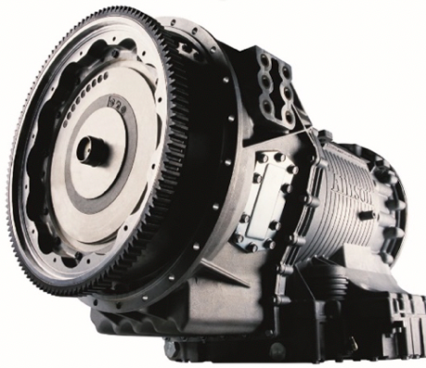  © Allison Transmission | VEICAR opted for a fully automatic Allison 4000 Series™ transmission with retarder rather than an automated manual transmission, mainly due to the performance advantages of the torque converter over a dry clutch.
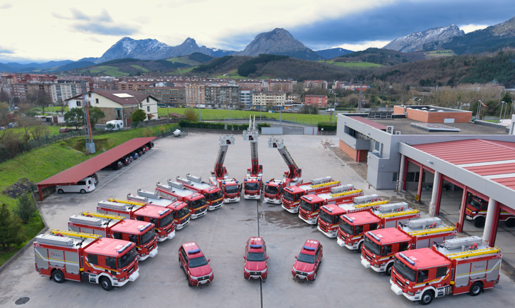  © VEICAR | The Vizcaya Provincial Council Fire Prevention, Firefighting and Rescue Service has upgraded its fleet with 15 state-of-the-art vehicles fitted with Allison fully automatic transmissions. These vehicles will be deployed at the Urioste, Basauri, Artaza, Iurreta, Gernika, Zalla and Derio fire stations
© VEICAR | “The vast majority of our fire trucks are equipped with Allison automatic transmissions. We consider them an indispensable firefighting tool as they maximize vehicle performance, and greatly improve acceleration, reliability and safety. In addition, their superior acceleration and maneuverability are beyond question, which is vital when there is not a second to be wasted. Most urban firefighters/drivers prefer them because they provide greater safety. And if that weren't enough, the vehicles reach the final years of their service life in better condition,” said Carlos Prieto-Puga González, CEO at VEICAR.
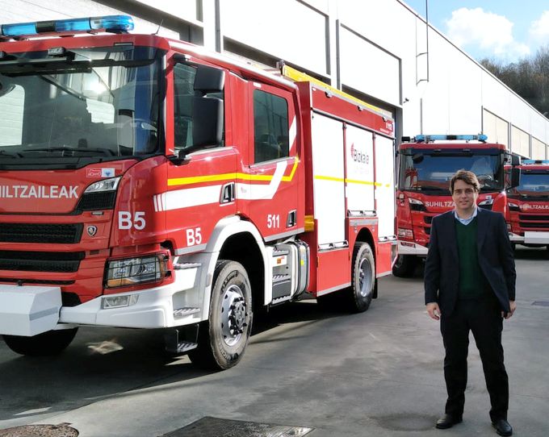  © VEICAR | "Allison transmissions have demonstrated exceptional reliability and durability in the most demanding conditions, and are the transmission of choice for firefighting fleets around the world. As regular users of these transmissions, we have no doubts whatsoever. As bodybuilders, we are always much happier when vehicles are equipped with Allison,” said Carlos Prieto-Puga González
© Allison Transmission | “The easy maneuverability of the vehicles simplifies the drivers' work. They don't have to shift gears and can concentrate fully on the job and the road when travelling at high speed. And with Allison, vehicles can include up to two power take-offs (PTOs) to keep hydraulic equipment working correctly, even while the vehicle is in motion,” said Trond Johansen, European Key Fleets and Market Development Manager at Allison Transmission.

