Civil Protection in North Rhine-Westphalia: Federal State Opts for MAN TGM with Allison Fully Automatic Transmission

The federal state of North Rhine-Westphalia (NRW), Germany, has ordered 109 new LF 20-KatS fire-fighting vehicles on MAN TGM 18.340 chassis with Allison 3000 Series™ fully automatic transmissions. A total of 38 vehicles have already been delivered to local fire departments, with another 30 scheduled for delivery by September 2021 and the rest to quickly follow. The Institut der Feuerwehr Nordrhein-Westfalen (IdF – fire brigade institute of North Rhine-Westphalia) in Münster had opted for this vehicle configuration to maximize driver control, comfort and economy.

MÜNSTER, Germany, January 2021 – North Rhein-Westphalia is investing heavily in disaster management. On behalf of the North Rhine-Westphalian Ministry of the Interior, the Institut der Feuerwehr NRW (IdF NRW), the largest German fire department training facility, has ordered 109 completely identical Magirus LF20-KatS vehicles on MAN TGM 18.340 BB 4x4 chassis, with Euro 6 emission standard and Allison 3000 Series™ fully automatic transmissions. To date, this is the largest procurement project for firefighting vehicles in the state of North Rhine-Westphalia.

Due to the COVID-19 pandemic, delivery of the 109 MAN TGM vehicles to the local fire departments in the districts and independent cities in North Rhine-Westphalia has been delayed and is now expected to be completed by the end of 2022. Rather than an automated manual transmission (AMT), the IdF NRW opted for fully automatic transmissions with a torque converter and continuous power to the wheels. The decisive factors were improved acceleration and excellent off-road capability, reduced wear and, above all, the increase in driver control and comfort for the vehicle’s nine-member crew.

“It is important to us that the overall configuration of this vehicle offers maximum safety for the crew. The smoother and safer the ride, the more confidence the crew has in the vehicle,” said Chief Fire Officer Sebastian Datema, Deputy Head of the Department of Technology and Technical Service at the Institut der Feuerwehr NRW. "We get very positive feedback from the local fire departments about the Allison fully automatic transmission. The intelligent transmission logic thinks for itself and supports the driver both on- and off-road."

The MAN TGM 18.340 BB 4x4 with Magirus body is driven by an Allison 3000 Series™ fully automatic transmission and a 6-cylinder diesel engine with Euro 6 emission standard. The diesel engine has an output of 251 kW (340 PS) and can achieve a maximum speed of 100 km/h. The all-wheel drive provides off-road capability at any time. The LF 20 KatS NRW is able to drive through water up to 90 cm and can maneuver at a tilt angle of up to 32 degrees, which also has a very positive effect on cornering. The water tank has a capacity of 1,000 liters. The entire equipment exceeds standard specifications by far and has been adapted to the application scenarios encountered in North Rhine-Westphalia.

The LF20-KatS disaster control and civil protection vehicles must be ready for operation when everything else fails. They carry out tasks in case of nuclear, biological or chemical (NBC) threats and floods. They provide emergency medical services and assistance and support for people. In addition, the vehicles are used for local fire protection in the communities.

“In recent years we have had an increase in incidents for which these powerful vehicles are needed," said Matthias Kalthöner, Government Fire Director and Head of the Technology and Technical Service Department at IdF NRW. “These are, for example, supra-local assistance in so called large-scale operations and disasters such as floods, forest fires, severe weather conditions or NBC defense. The vehicles are currently enjoying a high level of acceptance among local fire departments."

The Allison 3000 Series™ transmission has been specifically designed for the requirements of emergency vehicles. “We recommend fully automatic transmissions for these vehicles, especially since the fire services are largely run by volunteer firefighters,” said Stephan Marker, Germany Market Development Manager at Allison Transmission. “The easy maneuverability of the vehicles simplifies the work of the drivers. They don't have to change gears and can focus fully on the job and the road, moving at speed. Allison's patented torque converter multiplies engine torque during start-up and acceleration. There is no interruption in traction during gear shifts but a seamless transfer of power to the wheels."

“With the series release of Allison transmissions, MAN has responded to the request of numerous fire departments for a drive configuration that offers outstanding performance, reliability and ease of operation in extremely challenging conditions,” said Harald Rosenauer, Account Manager for MAN at Allison Transmission. “Allison’s torque converter transmission enables MAN engines to deliver full power shifts. This enables the MAN TGM chassis to provide exceptional traction and acceleration for emergency vehicles.”

Allison fully automatic transmissions have demonstrated exceptional reliability and robustness in the most demanding conditions and as a result are used by numerous firefighting fleets worldwide.

Overview MAN TGM 18.340 4x4 BB, LF20-KatS with Allison 3000 Series™ transmission
and Magirus body
Customer | The state of North Rhine-Westphalia
Chassis (manufacturer) | MAN
Chassis (model) | TGM 18.340 4x4 BB Euro 6 (all-wheel drive)
Body (manufacturer) | Magirus
Body (model) | LF20-KatS
Engine, emission standard, cubic capacity | 6-cylinder diesel engine, Euro 6, 6871 ccm
Engine output, torque | 251 kW (340 PS) @ 2200 rpm  1250 Nm @ 1200 – 1800 rpm
Transmission | Allison 3000 Series™ transmission with shift logic controller for fire fighting vehicles and retarder
Extinguishing agent | 1000 Liters of water
Overview equipment of LF20-KatS | According to DIN 14530 Part 8, additionally among others:  - Boosterline bag, D hose (forest-fire set 2 x D, distributor, 2 hollow stream nozzle)  - Additional power chain saw  - Additional wastewater pump  - Reciprocating saw  - Generating foam through incline inductor  - Rear warning system  - Light mast  - Boosterline distributor (2 x)  - Quick water dispensing system  - Air conditioning and auxiliary heating for the crew cab

January 2021

About the Institut der Feuerwehr (IdF) Nordrhein-Westfalen
The IdF in Münster, with approximately 180 employees, is the largest fire department training facility in Germany and at the same time the only training center for the advanced professional service in the fire department. The IdF is the central education and training center of the state of North Rhine-Westphalia for matters concerning fire protection, emergency services and disaster control and is under the authority of the Ministry of the Interior of North Rhine-Westphalia. On behalf of the Ministry of the Interior and Municipal Affairs (MIK) NRW, the IdF conducts tender procedures for the procurement of firefighting and disaster control vehicles.

About Allison Transmission, Inc.
Allison Transmission (NYSE: ALSN) is the world’s largest manufacturer of fully automatic transmissions for medium- and heavy-duty commercial vehicles and medium- and heavy-tactical U.S. defense vehicles, as well as a supplier of commercial vehicle propulsion solutions, including electric hybrid and fully electric propulsion systems. Allison products are used in a wide variety of applications, including on-highway trucks (distribution, refuse, construction, fire and emergency), buses (school, transit and coach), motorhomes, off-highway vehicles and equipment (energy, mining and construction applications) and defense vehicles (wheeled and tracked). Founded in 1915, the company is headquartered in Indianapolis, Indiana, USA. With a market presence in more than 80 countries, Allison has regional headquarters in the Netherlands, China and Brazil with manufacturing facilities in the U.S., Hungary and India. Allison also has approximately 1,500 independent distributor and dealer locations worldwide. For more information, visit allisontransmission.com

Contacts:
Susanne Megill Miranda Jansen
geldermannKommunikation Allison Transmission Europe B.V.
susanne.megill@geldermannkommunikation.de miranda.jansen@allisontransmission.com
Tel: +49 (0)2801- 9 88 44 77 Tel: +31 (0)78 - 6422 174
Klever Straße 2 Baanhoek 188
46509 Xanten - Germany 3361 GN Sliedrecht – The Netherlands

Images (for editorial use only)
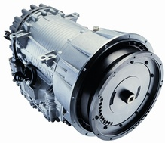  © Allison Transmission | Rather than an automated manual transmission (AMT), the IdF NRW opted for an Allison 3000 Series™ fully automatic transmission. The decisive factor was the performance benefits of the torque converter compared to a dry clutch.
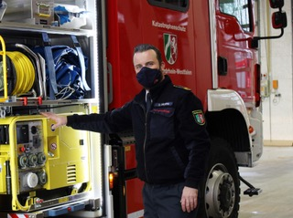  © Allison Transmission | "We get very positive feedback from the local fire departments about the Allison fully automatic transmission. The intelligent transmission logic thinks for itself and supports the driver both on- and off-road," says Chief Fire Officer Sebastian Datema, Deputy Head of the Department of Technology and Technical Service at the Institut der Feuerwehr NRW.
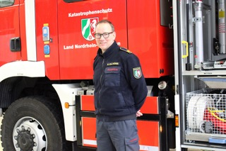  © Allison Transmission | “The vehicles are currently enjoying a high level of acceptance among local fire departments,” said Matthias Kalthöner, Government Fire Director and Head of the Technology and Technical Service Department at IdF NRW.
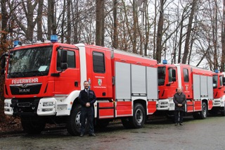  © Allison Transmission | A total of 38 vehicles have already been delivered to local fire departments, with another 30 scheduled for delivery by September 2021 and the rest to quickly follow. The Institut der Feuerwehr Nordrhein-Westfalen (IdF – fire brigade institute of North Rhine-Westphlia) in Münster had opted for the Allison Automatic to maximize driver control, comfort and economy.  (left: Sebastian Datema, IdF NRW;  right: Stephan Marker, Allison Transmission)
© Allison Transmission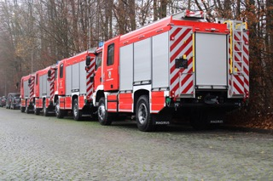 | The federal state of North Rhine-Westphalia (NRW), Germany, has ordered 109 new LF 20-KatS fire-fighting vehicles on MAN TGM 18.340 chassis with Allison 3000 Series™ fully automatic transmissions.
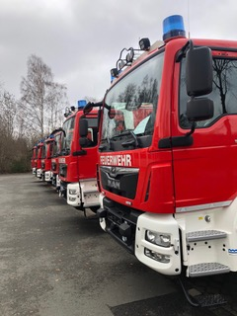  © Institut der Feuerwehr NRW | The MAN TGM 18.340 BB 4x4 with Magirus body is propelled by an Allison 3000™ series fully automatic transmission and a 6-cylinder diesel engine with Euro 6 emission standard. The diesel engine has an output of 251 kW (340 PS) and can achieve a maximum speed of 100 km/h.

