Offenbach am Main, January 2021

Falken announced as "Official Partner of the Nürburgring Endurance Series"

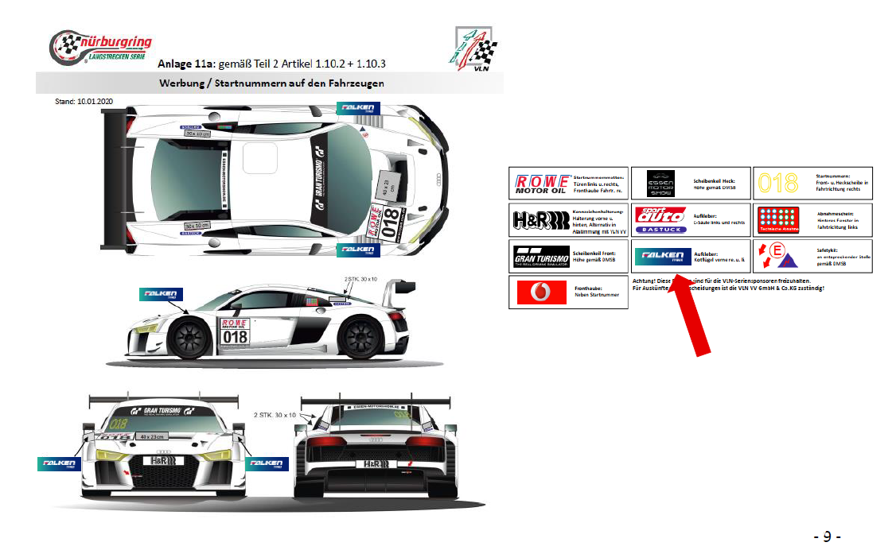

Falken is expanding its motorsport commitment and will be the new Nürburgring Endurance Series (NLS) sponsor for the 2021 season. The agreement sees the tyre brand secure prominent logo placement on the front wings of all competing race cars in the series. In addition, there will be significant trackside signage on the start/finish straight and winners' podium, as well as branding on the official NLS homepage with further promotional opportunities planned.

Nine races have been planned for this season's racing calendar of the world's largest motorsport championship held on the iconic Nürburgring Nordschleife.

Falken has been a long-term entrant in the NLS (previously known as the VLN) series as well as the 24H-races since 1999, competing in a range of cars, most recently with two identical Porsche, which are scheduled to return in 2021.

"For more than 20 years, Falken has embraced the tough competition synonymous with the Nürburgring Nordschleife, both with its own team as well as a partner of the Nürburgring Endurance Series and has displayed a strong commitment to the motorsport home," says Christian Stephani, managing director VLN VV GmbH & Co. KG. "Especially in these times, a new sponsorship commitment is anything but a matter of course. It is only through strong partners like Falken that we are able to consistently develop the Nürburgring Endurance Series and ensure it thrives in the future."

"The myth of the Nordschleife has always held a great attraction for us," says Dennis Wilstermann, marketing supervisor, Falken Tyre Europe GmbH, about the commitment. "For a long time now, we have enjoyed working together with the Nürburgring as a trusted and successful partner. Put simply, there is no better track to demonstrate the performance of our tyres than the Nordschleife."

Falken Tyre Europe
Falken Tyre Europe GmbH is the European affiliate of Japanese tyre manufacturer Sumitomo Rubber Industries Ltd. (SRI); with more than 39,233 employees, it is the fifth largest tyre manufacturer worldwide. In 2001 and 2014 SRI was selected to appear in the Thomson Reuters ‘Top 100 Global Innovators’ list of the world’s most pioneering companies. From its location in Offenbach, Main, the company markets and sells a complete tyre portfolio for passenger cars, light trucks, trucks, pick-ups and SUVs as original equipment and for the entire European retrofitting market. All Falken factories comply with the ISO 9001, IATF 16949 as well as environmental standard ISO14001. Developed and tested in the world’s most demanding racing series, Falken tyres provide maximum driving pleasure. The Falken brand is involved in exciting and high technology platforms such as motorsport with two identically constricted Porsche 911 GT3 R, at the BORUSSIA PARK stadium, which is the stadium of Bundesliga club Borussia Mönchengladbach.

Media Contact: Falken Tyre Europe GmbH
Kerstin Schneider, Tel.: + 49 69 247 5252 676
Fax: +49 69 247 5252 89676
E-Mail: pr@falkentyre.com

