UROVESA to supply Spanish Armed Forces with 663 VAMTACs fitted with Allison automatic transmissions

Galician company UROVESA, a provider of special off-road vehicles for civil and defense missions worldwide, has secured a contract to supply the Spanish Armed Forces with 663 VAMTAC ST5s fitted with Allison 1000 Series™ fully automatic transmissions. Transdiesel, Allison’s official distributor in Spain, played a key role as advisor to UROVESA in this project.
MADRID, September, Spain – Following a process of many months, and subsequent to the submission of prototypes for assessment, the Spanish Ministry of Defense awarded UROVESA a contract for the delivery of a maximum of 663 VAMTACs (High Mobility Tactical Vehicles) in the period 2020-2025. This versatile modular vehicle is designed to withstand the toughest working conditions. It combines excellent mobility with a high payload. All the vehicles will be fitted with Allison 1000 SeriesTM automatic transmissions and Allison’s Electronic Controls, which further enhances vehicle functioning.
“Through the years, Allison has remained faithful to values that continue to be a hallmark of the company today: quality, reliability, durability, the quest for state-of-the-art technology and commitment to our clients,” said Trond Johansen, Market Development Manager at Allison Transmission in Spain. “With extensive experience in the design and production of automatic transmissions for defense vehicles, Allison is now providing its expertise and technology to equip the VAMTAC ST5s for the Spanish Armed Forces.”
“Allison Transmission made a significant contribution to our submission to the Spanish Ministry of Defense, providing technical expertise in the process of fine tuning the prototypes, integrating and validating them with the engine chosen by our company,” said Justo Sierra, President and CEO at UROVESA.
Transdiesel carried out the onsite vehicle application and performance studies, and advised UROVESA on the selection of the most suitable transmission and accessories. In addition, Transdiesel supplied parts, parametrized the electronic controls in accordance with vehicle usage requirements and carried out a review of installations.
“Allison fully automatic transmissions are perfectly suited to these types of vehicles and are also extremely reliable. The ease of use and great acceleration afforded by these transmissions, which would not be possible with manual transmissions, enables vehicles to climb grades of over 45 degrees, so greater than 100%,” said Jérôme Zanon, CEO at Transdiesel. “Allison fully automatic transmissions are widely used for defense applications. The VAMTAC achieves maximum performance through power-to-weight ratio optimization, making it a vehicle of choice for many armies and special forces operations worldwide.”
UROVESA will supply these multipurpose vehicles to the Spanish Army, Air Force and Navy. Other armed forces and security forces, such as the Civil Guard, may also make use of the vehicles. “The goal is for all our armed forces to use the same equipment. This enables optimization of logistical resources, training, maintenance and spare parts,” said Sierra. “Moreover, the VAMTAC can be configured for up to 20 different applications, including ambulances, personnel carriers, mobile command vehicles, missile carriers, etc.”
The VAMTACs will be supplied with three different configurations:
- Unarmoured or lightly armoured “High Mobility Tactical” vehicles
- “High-Protection” vehicles, which are heavily armoured against bullets, anti-personnel mines, anti-tank mines and Improvised Explosive Devices (IED)
- Vehicles equipped with Deep Fording Systems, which are heavily armoured and offer the additional capacity of being able to operate for two hours in salt water at depths of up to 1.5 m, making them ideal for landing operations.
VAMTACs also incorporate all the features needed for defense use: an all-wheel drive system which enables the vehicle to move at full load on a single wheel without losing traction; the possibility of being parachuted from low altitudes and carried by helicopter as an external load; compatibility with kerosene-derived aviation fuel; and a driver-activated central tire inflation system. The VAMTACs in the Spanish Ministry of Defense order include 135 kW and 180 kW Steyr diesel engines.
Allison: a multitude of benefits for military applications
Allison transmissions are widely used in the defense sector and offer all the features needed for these challengingapplications. These include a compact propulsion, steering and braking system for enhanced stability and precision. Allison’s transmission-mounted Power Take-Off (PTO) provide installation flexibility and the ability to provide power to vehicle-mounted specialty equipment such as hydraulic pumps and mechanical fan drives.
“Allison 1000 Series transmissions and Electronic Controls provide three main advantages,” said Sierra. “Firstly, great ergonomics and driving comfort, enabling vehicle operators to drive in high-risk environments and tough conditions (instability, brusque vibrations, poor traction, etc.) with both hands on the wheel and eyes on the road, without having to worry about gear-shift errors. Secondly, the great reliability of the engine mechanics and the entire drivetrain. And, thirdly, excellent durability.”
VAMTAC ST5: innovation-based versatility and security
First manufactured in 1998 by UROVESA in Spain, the VAMTAC platform can adapt to different bodywork, loads, power outputs, equipment and accessories enabling multiple configurations. It is a vehicle born of UROVESA innovation. “Constant innovation is vital, and at UROVESA we offer state-of-the-art solutions in the form of new models and versions that perfectly match the needs of our clients,” said Sierra.
“Due to customer requirements and the evolution of the main vehicle components, the VAMTAC is constantly evolving. We are extremely proud to have been a part of the VAMTAC since its birth and to remain at the side of the Spanish manufacturer of such unique vehicles,” said Zanon.
Allison and UROVESA: joint vision of a bright future
“UROVESA is a company that constantly looks to the future and, as such, always incorporates Allison’s periodic product developments and innovations,” said Zanon. “The technical teams from the two companies have an excellent working relationship and have been collaborating since the 1980s. Although their customers are varied and spread all over the globe, all of them share the same extremely high product-quality procurement standards.”
In these difficult times, arising from the COVID-19 pandemic, UROVESA vehicles have played a major role in helping the Spanish Armed Forces to disinfect care homes and other institutional buildings, and in supervising the security of critical infrastructures.
“The importance of cutting-edge equipment capable of responding to all unforeseen situations has been underlined. These vehicles have extraordinary capabilities and offer optimum performance in the most extreme circumstances,” said Sierra.
UROVESA is gradually entering specialized markets and the company is reinforcing its position in the European market through increased participation in procurement procedures and projects. It is also focusing on manufacturing flexibility in order to offer tailored solutions. In 1989, UROVESA became the first vehicle manufacturer in Spain to fit its civil and defense off-road vehicles with Allison transmissions. Since then, the company has manufactured over 7,000 vehicles with Allison automatic transmissions. “The result has been a complete success in terms of both customer satisfaction and reliability. There have been practically no incidents,” said Sierra.
About Allison Transmission
Allison Transmission is the world’s largest manufacturer of fully automatic transmissions for medium- and heavy-duty commercial vehicles and medium- and heavy-tactical U.S. defense vehicles, as well as a supplier of commercial vehicle propulsion solutions, including electric hybrid and fully electric propulsion systems. Allison products are used in a wide variety of applications, including on-highway trucks (distribution, refuse, construction, fire and emergency), buses (school, transit and coach), motorhomes, off-highway vehicles and equipment (energy, mining and construction applications) and defense vehicles (wheeled and tracked). Founded in 1915, the company is headquartered in Indianapolis, Indiana, USA. With a market presence in more than 80 countries, Allison has regional headquarters in the Netherlands, China and Brazil with manufacturing facilities in the U.S., Hungary and India. Allison also has approximately 1,500 independent distributor and dealer locations worldwide. For more information, visit allisontransmission.com.

Press contacts:
Nuria Martí  Alarcón & Harris  Asesores de Comunicación y Marketing  nmarti@alarconyharris.com  +34 91 415 30 20  Avda. Ramón y Cajal, 27  28016 Madrid | Miranda Jansen  Allison Transmission Europe B.V.  Marketing Communications  miranda.jansen@allisontransmission.com  +31 (0)78 6422174  Baanhoek 188  3361GN Sliedrecht (Países Bajos)
Photographs
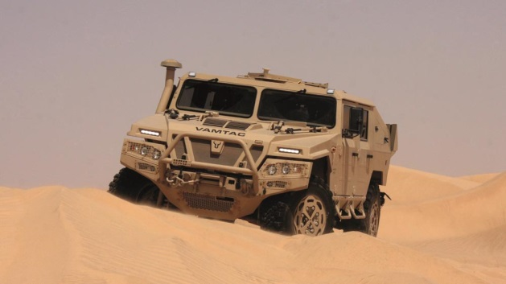 | VAMTAC (High Mobility Tactical Vehicle). This versatile modular vehicle, equipped with an Allison Automatic, is designed to withstand the toughest working conditions. It combines excellent mobility with a high payload.
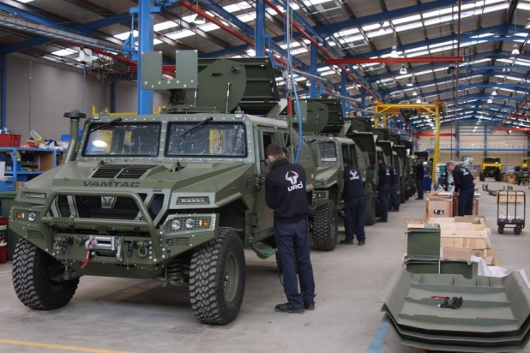 | The VAMTAC platform, equipped with an Allison Automatic, can adapt to different bodywork, loads, power outputs, equipment and accessories enabling multiple configurations. It is a vehicle born of UROVESA innovation.
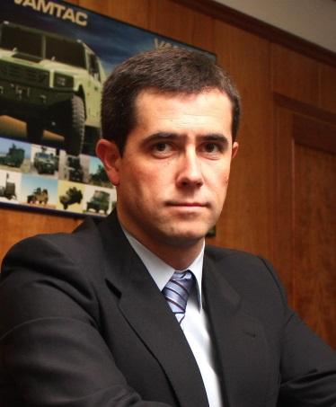 | Allison Transmission made a significant contribution to our submission to the Ministry of Defense, providing technical expertise in the process of fine tuning the prototypes, integrating them and validating them with the engine chosen by our company,” said Justo Sierra, President and CEO at UROVESA.
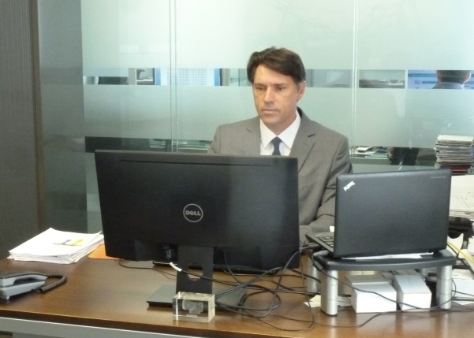 | “Allison fully automatic transmissions are perfectly suited to these types of vehicles and are also extremely reliable. The ease of use and great acceleration afforded by these transmissions, which would be impossible with manual transmissions, enables vehicles to climb grades of over 100%,” said Jérôme Zanon, CEO at Transdiesel.
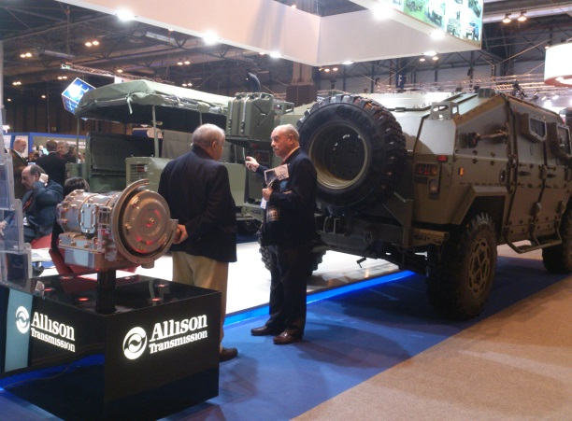 | UROVESA is gradually entering specialized markets and the company is reinforcing its position in the European market through increased participation in procurement procedures and projects.

