Allison automatics provide driver comfort during concrete transport

Because they are environmentally friendly and comfortable, trucks with Allison’s fully automatic transmissions are replacing vehicles with Automated Manual Transmission (AMT) transmissions as H. Grann Åkeri in Stockholm renews their concrete transport fleet.

STOCKHOLM, November, 2019 - H. Grann Åkeri uses eight trucks to transport concrete for the construction company Skanska to construction sites in the Stockholm area. The haulage started 60 years ago with mixed construction transports, but the last 20 years have focused entirely on the transport of concrete.

“The first truck in our company fitted with an Allison transmission was a Volvo FE 320. It made us discover the benefits of a fully automatic transmission for our kind of driving in heavy city traffic and a lot of reversing in crowded construction sites,” said Roger Grann, H. Grann Åkeri CEO and son of the founder, Håkan Grann.

In 2018, they bought their second Allison-equipped truck, a Scania P360*4 6x2 with steering on the first and last axle. Two more exactly the same vehicles have been ordered by Scaniabilar Stockholm AB for delivery in January 2020, which will replace two older AMT-equipped trucks. The automatic transmissions in all cases are Allison Transmission's 3000-Series™ fully automatics.

“Our drivers feel that the automatic gearbox provides a much more harmonious working environment with smoother movements thanks to the torque converter, which provides a continuous power transmission to the drive wheels without power loss at the moment of gear change” said Grann. “It also means faster acceleration, which could very well mean that we can have more deliveries per day than with other gearbox solutions. Without load, we accelerate as fast as a car.”

As far as the economics are concerned, Grann said that the slightly higher purchase price for an Allison fully automatic is more than paid back by lower maintenance costs throughout its lifetime. “We have had no problems with existing Allison fully automatic machines. Managing oil and filter changes according to the manufacturer's recommendations has so far been the only costs we have had. This means more time in the streets and less in the workshop, which of course is just as important on the income side as missing workshop bills,” said Grann.

Another advantage that Grann has noted is that a truck with a smaller engine and fully automatic transmission performs the same job as one with a larger engine and AMT transmission. “Of course, a smaller engine is both cheaper and less heavy, so you can carry more load without exceeding any weight limits. All of this together makes the investment cost more than offset the benefits over time. In addition, a smaller engine emits less exhaust gases, so the environment can also thank us and congratulate us on our choice,” said Grann.

About Allison Transmission
Allison Transmission (NYSE: ALSN) is the world's largest manufacturer of fully automatic transmissions for medium- and heavy-duty commercial vehicles. Allison transmissions are used in a variety of applications including refuse, construction, fire, distribution, bus, motorhomes, defense and energy. Founded in 1915, the company is headquartered in Indianapolis, Indiana, USA. With a market presence in more than 80 countries, Allison has regional headquarters in the Netherlands, China and Brazil with manufacturing facilities in the U.S., Hungary and India. Allison also has approximately 1,400 independent distributor and dealer locations worldwide. For more information, visit allisontransmission.com.

Contacts
Kenneth Brinkeby Miranda Jansen
Brinkeby Public Relations AB Allison Transmission
+46 739 875 867 +31 78-6422 174
k.brinkeby@icloud.com miranda.jansen@allisontransmission.com

Images
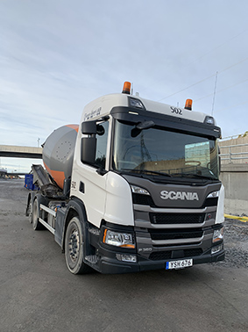  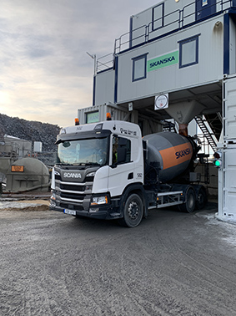 | "In our type of driving in heavy urban traffic and a lot of reversing on tight construction sites, a fully automatic transmission is a big advantage," said the company's CEO Roger Grann.  Photo: H.Grann Åkeri AB  H. Grann Åkeri transports concrete for the construction company Skanska with eight concrete trucks to construction sites in the Stockholm area.  Photo: H.Grann Åkeri AB

