FOR IMMEDIATE RELEASE
TOMRA’S NIMBUS SORTER SUCCESSFULLY AUTOMATES
CONFECTIONERY SORTING AT SWIZZELS MATLOW
Swizzels Matlow, a family business that produces sugar confectionery in the United Kingdom, has chosen TOMRA’s Nimbus optical sorter to automate the sorting process of its ‘Drumstick Squashies’ in order to meet fast-growing demand while ensuring the consistently excellent quality of the product.
Leuven, Belgium, 27 January 2019 - Swizzels is one of the longest-running sugar confectionery factories in the world, having celebrated its 90th anniversary in 2018. They produce much-loved heritage brands, such as the iconic ‘Love Hearts’, as well as new innovations. The factory, based in Derbyshire, employs more than 500 people and covers over 20,000 square metres. In 2018, it produced 20,000 tonnes of Love Hearts, Refreshers, Drumstick Lollies, Double Lollies, Parma Violets, Rainbow Drops and Drumstick Squashies.
Only the best confectionery for the customer
Swizzels have chosen TOMRA’s Nimbus optical sorter to handle the delicate sorting operation of their ‘Drumstick Squashies’, whose growing popularity has led to a fast increase in demand: “We used manual labor to remove any imperfect sweets that may have been created during the process. Our desire to provide only product of the highest quality to our consumers drove us to seek an alternative solution to manual sorting in order to improve the effectiveness whilst also delivering cost benefits to the business,” explains Matt Whatcott, Business Unit Manager (Jellies) at Swizzels Matlow.
The proof is in the confectionery
Nicolas Stein, Director of Stein Solutions, TOMRA’s agent in the UK, knew that the Nimbus optical sorter would be the perfect solution for Swizzels: “We invited them to the TOMRA Demonstration Center in Belgium, so they could try the Nimbus on their product and see first-hand how effective and easy to use it is. The Nimbus is used for a variety of products, but Swizzels were one of the first to test the machine in this specific application.”
The events proved him right: “The visit to the demo facility was highly beneficial and allowed us to see the equipment running with our product and to witness the results first-hand. We were able to make observations, ask questions and build a rapport with the team in Belgium. Having invested substantial effort in researching various alternative solutions, the demonstration provided us with confidence that this was the best and most appropriate solution for our process and allowed us to make an informed decision on progressing to purchase.”
The machine was delivered very quickly and has been operating at the Swizzels’ facility for a year to their great satisfaction.

State-of-the-art technology for reliable detection
The Nimbus represents a new generation of sorting solutions that separate products in free-fall. The product is fed onto a vibratory conveyor that spreads the ‘Drumstick Squashies’ evenly and in a single layer. It then goes into a free-fall and passes the scanning area, where several technologies are combined to detect different types of defects such as mis-shaped sweets or multiple sweets joined together.
During the free-fall, the product is inspected with laser scanning technology to identify contaminated products or foreign objects that are not visible to the naked eye. Special high-resolution cameras developed by TOMRA sort the product based on color and outline. In addition, the Nimbus can separate the articles by biological characteristics. This combination of technologies perfectly addresses the challenge of reliably detecting imperfect products.
When a defect is detected, a powerful burst of air removes the imperfect product from the stream. It is then inspected a second time to make sure no good product is rejected.
Matt Whatcott explains: “Before using a TOMRA sorter, we used manual labor to remove any imperfect sweets that may have been created during the process. The task was challenging due to sweets passing by the manual inspection operators with one side face-down on a conveyor. This meant that it was not always possible for them to identify a defect as the inspection only covered around 60% of the surface area of the sweets. The inspection task was also monotonous, meaning that focus could wane over time.
“TOMRA’s Nimbus has enabled us to establish a more automated production line with greater rigour around the quality inspection of our product. We have much higher confidence in our ability to supply sweets that are only of the optimum standard to our consumers.”
Focus on the customer’s specific requirements
The Nimbus sorter is also a very good fit with Swizzels’ space and operational requirements. “The footprint of the machine was also critical, since the space available in the factory was very limited, and the Nimbus is a very compact machine which can handle a high product throughput,” explains Nicolas Stein.
Another advantage of the machine is that it was especially designed and proven in dusty environments, making it particularly well suited for conditions at the Swizzels factory which can become dusty with the starch. It is also easy to maintain and operate, as the free-fall principle means there are no moving parts on the machine.
A satisfied customer
Matt Whatcott concludes: “TOMRA’s Nimbus has enabled us to establish a more automated production line with greater rigour around the quality inspection of our product. We have much higher confidence in our ability to supply sweets that are only of the optimum standard to our consumers. It has allowed us to achieve a more consistent, high quality product, develop our business and meet the demand of our consumers.”
- For more information about TOMRA Food: www.tomra.com/food

About TOMRA Food
TOMRA Food designs and manufactures sensor-based sorting machines and integrated post-harvest solutions for the food industry, using the world’s most advanced grading, sorting, peeling and analytical technology. Over 8,000 units are installed at food growers, packers and processors around the world for fruits, nuts, vegetables, potato products, grains and seeds, dried fruit, meat and seafood. The company’s mission is to enable its customers to improve returns, gain operational efficiencies, and ensure a safe food supply via smart, useable technologies. To achieve this, TOMRA Food operates centers of excellence, regional offices and manufacturing locations within the United States, Europe, South America, Asia, Africa and Australasia.
TOMRA Food is member of the TOMRA Group that was founded on innovation in 1972 that began with design, manufacturing and sale of reverse vending machines (RVMs) for automated collection of used beverage containers. Today, TOMRA has ~95,700 installations in over 80 markets worldwide and had total revenues of ~7.4 billion NOK in 2017. The Group employs ~3,420 globally, and is publicly listed on the Oslo Stock Exchange. (OSE: TOM). The TOMRA Group continues to innovate and provide cutting-edge solutions for optimal resource productivity within two main business areas: Collection Solutions (reverse vending and material recovery) and Sorting Solutions (recycling, mining and food sorting). For further information about TOMRA, please see www.tomra.com

Media Contacts:

Nuria Martí, Alarcon & Harris PR  Avda. Ramón y Cajal, 27  28016 Madrid, Spain  T: +34 91 415 30 20  E: nmarti@alarconyharris.com  W: www.alarconyharris.com | Marijke Bellemans  Senior Marketing Communication Coordinator TOMRA Food, Compac, and BBC Technologies  Research Park Haasrode 1622 – Romeinse straat 20  3001 Leuven, Belgium  T: +32 (0)16 74 28 17 M: +32 (0)476 74 19 18  E: marijke.bellemans@tomra.com  W: www.tomra.com/food
Picture subscripts:

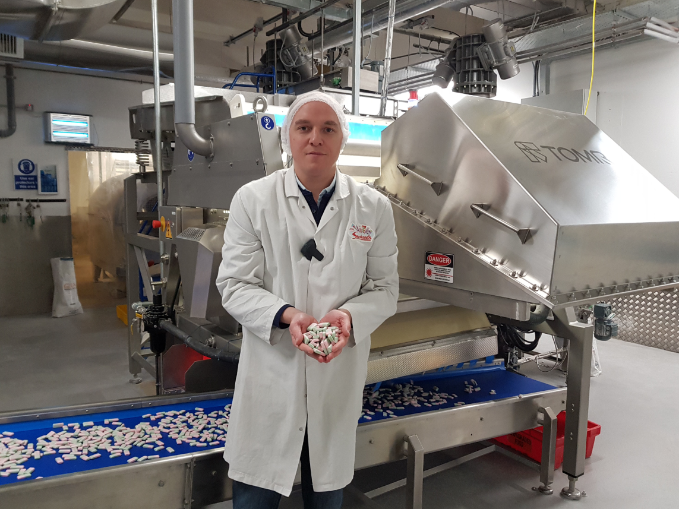
Matt Whatcott, Business Unit Manager (Jellies) at Swizzels

