First Volvo hydrostatic road sweeper with an Allison transmission to debut at IFAT 2018

Fully automatic transmission provides a variety of benefits, including increased productivity, lower cost of ownership and greater driver comfort

MUNICH, Germany – The first Euro 6 hydrostatic sweeper equipped with an Allison fully automatic transmission on a Volvo chassis will be shown at IFAT, the World’s Leading Trade Fair for Water, Sewage, Waste and Raw Materials Management, May 14-18.

Only recently have hydrostatic sweepers been equipped with fully automatic transmissions, which offer increased productivity, lower cost of ownership and greater driver comfort.

The single-engine, truck-mounted road sweeper is based on a Volvo chassis type FL 250 4 x 2 with Johnston VS651dual body and will be on display at the Johnston Sweepers booth (C5.427/526). The vehicle has a 7.7 liter Euro 6 diesel engine with 188 kW (252 hp) that delivers 969 Nm of torque and is equipped with an Allison 3200 transmission.

By combining an Allison transmission with a hydrostatic transmission, transport mode and working mode of the sweeper can ideally be coordinated.

In transport mode, the Allison transmission enables conventional driving speeds up to 80 km/h. The mechanical switchover gearbox with integrated hydrostatic drive for stepless speed control in sweeping mode, which is integrated into the drivetrain, is switched straight through and is thus bridged during transport position.

For sweeping operation, the hydrostatic transmission is switched to working mode and the two-stage working drive now allows infinitely variable speed control from zero to 40 km/h for fast gear and 0.1 to 16 km/h for sweeping mode. The hydraulic drive of turbine, water pumps and brushes is done by hydraulic pumps, which are mounted on the hydrostatic transmission.

“The speed of the vehicle can be regulated infinitely and independent of the suction performance. And the operation can ideally be adapted to municipal circumstances,” said Peter Bantlin, European sales manager for Johnston Sweepers U.K. “The Allison transmission eliminates shift shocks as well as manual shifting processes between the two modes, which significantly reduces stress and strains for the drivers.”

Due to the short wheelbase of 3,350 mm, the road sweeper is extremely maneuverable, which offers considerable advantages for street cleaning in narrow inner-city areas.

The vehicle also offers advantages in terms of fuel consumption and exhaust emissions. The Allison 3200 features a unique fuel-saving technology that automatically selects the optimum shift schedule based on duty cycle and road conditions. Moreover, the efficient coordination between the Allison 3200 and a hydrostatic unit eliminates the need for a second combustion engine, thereby reducing exhaust and noise emissions. And because a single-engine truck weighs less, it can carry a larger payload of swept materials.

Allison transmissions allow precise vehicle control and maneuverability. They use a torque converter instead of a traditional dry clutch to smoothly multiply engine torque during start-up and acceleration. Allison automatics deliver seamless uninterrupted power shifts for increased average speed, productivity and operator comfort. In addition, the maintenance for an Allison transmission requires less time and cost than for a manual or automated manual transmission (AMT), which periodically require downtime for clutch replacement.

Premiere vehicle goes to the Berliner Stadtreinigung
After IFAT, the vehicle is expected to be delivered to the Berliner Stadtreinigung (BSR) in June 2018 for a one-year testing. Roads, sidewalks and public spaces are cleaned around the clock in the capital city, that are about 1.33 million kilometers in Berlin per year. At the same time, the BSR returns nearly 55,000 tonnes of street sweepings and disposes it safely and with high quality. The emptying of 21,500 waste paper baskets as well as the cleaning of 210,000 gullies is also part of the services provided by the Berliner Stadtreinigung.

“We currently have around 650 vehicles equipped with Allison fully automatic transmissions and will gradually equip more vehicles of our fleet that have high stop-and-go driving conditions with fully automatic transmissions,” explains Wolfgang Wüllhorst, Head of fleet management Berliner Stadtreinigung. “The fact that there is now the environmentally friendly hydrostatic sweeper with Allison transmission on the sweeper market is a clear advantage for us, as the manufacturer of this drive technology promises increased driving comfort, reduced maintenance and lower exhaust emissions.”

Another vehicle has already been ordered and goes to the German Johnston dealer Thome-Bormann as a demonstration vehicle.

The Allison booth at IFAT 2018 is located in hall C6, booth 140.

Overview Volvo FL 250 4 x 2 with Allison 3200 fully automatic transmission
Chassis (manufacturer) | Volvo Trucks
Chassis (type) | Volvo FL 250 4 x 2
Body (manufacturer) | Johnston Sweepers Limited
Body (type) | Johnston VS651 dual
Wheelbase | 3.350 mm
Engine | 7,7 l diesel engine
Engine output | 188 kW (252 hp)
Torque | 969 Nm
Exhaust gas class | Euro 6
Transmission | Allison 3200 fully automatic transmission
Gross vehicle weight | 16 tonnes
Specials | Air suspension on rear axle

About Allison Transmission
Allison Transmission (NYSE: ALSN) is the world's largest manufacturer of fully automatic transmissions for medium- and heavy-duty commercial vehicles, and is a leader in electric hybrid-propulsion systems for city buses. Allison transmissions are used in a variety of applications including refuse, construction, fire, distribution, bus, motorhomes, defense and energy. Founded in 1915, the company is headquartered in Indianapolis, Indiana, USA and employs approximately 2,700 people worldwide. With a market presence in more than 80 countries, Allison has regional headquarters in the Netherlands, China and Brazil with manufacturing facilities in the U.S., Hungary and India. Allison also has approximately 1,400 independent distributor and dealer locations worldwide. For more information, visit allisontransmission.com.

Contacts
Stefanie Vitt  geldermannKommunikation  Agentur für Public Relations  stefanie.vitt@geldermannkommunikation.de  Tel: +49 (0)2801- 9 88 44 77  Klever Straße 2  46509 Xanten, Germany | Miranda Jansen  Allison Transmission  Marketing Communications  miranda.jansen@allisontransmission.com  Tel: +31 (0)78 - 6422 174  Baanhoek 188  3361 GN Sliedrecht, The Netherlands

Images (for editorial use only)
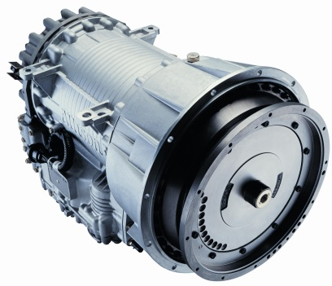  © Allison Transmission | Allison 3000 Series™ fully automatic transmissions are ideal for vehicles with engines up to 276 kW (370 hp).  Allison transmissions allow precise vehicle control and maneuverability. They use a patented torque converter instead of a traditional dry clutch, which smoothly multiplies engine torque during start-up and acceleration.
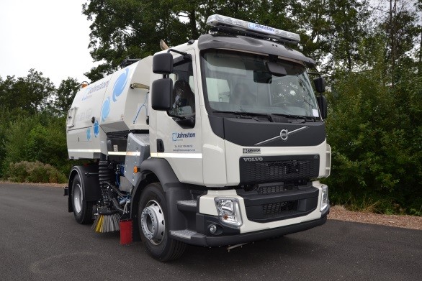  © Johnston Sweepers Limited | Sweeper manufacturer Johnston will present for the first time a Euro 6 hydrostatic sweeper with an Allison fully automatic transmission at IFAT, May 14-18.

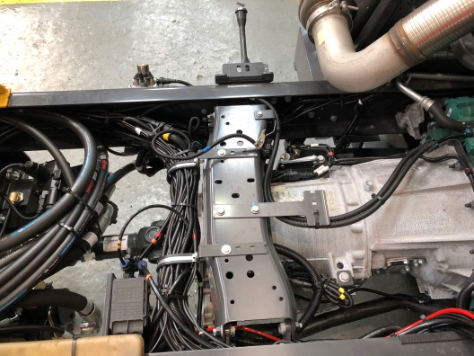  © Johnston Sweepers Limited | The single-engine, truck-mounted road sweeper is based on a Volvo chassis type FL 250 4 x 2 with Johnston VS651dual body and will be on display at the Johnston Sweepers booth (C5.427/526). The vehicle has a 7.7 liter Euro 6 diesel engine with 188 kW (252 hp) that delivers 969 Nm of torque and is equipped with an Allison 3200 transmission.
© Johnston Sweepers Limited | “The Allison transmission eliminates shift shocks as well as manual shifting processes between the two modes, which significantly reduces stress and strains for the drivers”, said Peter Bantlin, European sales manager for Johnston Sweepers U.K.

