Allison Transmission announces xFE models with technology to further increase fuel economy for its 1000 Series™ and 2000 Series™

Previously only available with select 3000 Series™ models, expanded xFE portfolio now enables smaller, medium-duty buses and trucks to also use even less fuel

INDIANAPOLIS – Oct. 5, 2017 – Allison Transmission today announced availability of its latest fuel economy technology for its 1000 Series™ and 2000 Series™. Referred to as xFE, designating extra fuel economy, the fully automatic bus and truck transmissions have demonstrated improvements up to 7 percent when compared to baseline models.

“Other than our electric hybrid products, xFE models represent the very best fuel economy technology we offer,” said John Coll, senior vice president of global marketing, sales and service for Allison Transmission. “Our goal with this expansion of the xFE portfolio is to also now achieve the best fuel economy from an automatic transmission in smaller, medium-duty buses and trucks.”

The 1000 Series and 2000 Series xFE transmissions have the same space claim and ratings as current models, but incorporate a redesigned torque converter damper coupled with the FuelSense 2.0 Max package. The damper enables first range lock up, delivering significantly more lock up operation and operating at lower engine speeds in higher ranges to further improve fuel economy. All xFE transmissions are compatible with alternative fuel engines.

“The new design works to achieve enhanced fuel economy in start-stop dense, low average speed duty cycles,” said Coll. “Transit and city buses are the ideal candidates for this technology and that’s why we’ve remained focused on those applications.”

First announced in 2015, xFE transmissions were exclusively available in the 3000 Series™ for bus applications. The new models represent the first expansion of the xFE portfolio and come standard with FuelSense 2.0.

Announced in March, FuelSense® 2.0 with DynActive™ Shifting delivers additional fuel savings beyond original FuelSense software. Through a set of proprietary software enhancements, the new FuelSense 2.0 uses DynActive Shifting to provide an infinitely variable combination of shift points and uses a learning algorithm to continuously find the ideal balance of fuel economy and performance. Available in three packages, FuelSense 2.0 allows fleets to optimize fuel economy and performance to their specific needs.

Allison transmissions use Continuous Power Technology™ to smoothly multiply engine torque and deliver more power to the wheels. Drivers with Allison transmissions experience better productivity, fuel economy, driver comfort, safety and operational flexibility than those with manual and automated manual transmissions (AMTs). Allison Automatics are globally recognized for their quality and reliability, and a greater overall economic value. This is demonstrated by the residual value that accompanies an Allison-equipped vehicle, as compared to a vehicle equipped with a manual, AMT or dual-clutch transmission (DCT).

About Allison Transmission
Allison Transmission (NYSE: ALSN) is the world's largest manufacturer of fully automatic transmissions for medium- and heavy-duty commercial vehicles, and is a leader in hybrid-propulsion systems for city buses. Allison transmissions are used in a variety of applications including refuse, construction, fire, distribution, bus, motorhomes, defense and energy. Founded in 1915, the company is headquartered in Indianapolis, Indiana, USA and employs approximately 2,600 people worldwide. With a market presence in more than 80 countries, Allison has regional headquarters in the Netherlands, China and Brazil with manufacturing facilities in the U.S., Hungary and India. Allison also has approximately 1,400 independent distributor and dealer locations worldwide. For more information, visit allisontransmission.com.

Contact
Craig Koven
Corporate Affairs & Communications
craig.koven@allisontransmission.com
317-242-3432

Image
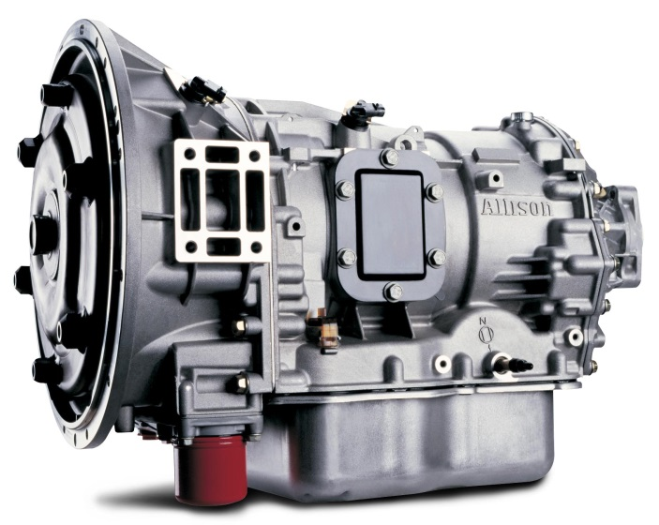  © Allison Transmission | Allison Transmission’s new 1000 Series™ and 2000 Series™ xFE transmissions have the same space claim and ratings as current models, but incorporate a redesigned torque converter damper coupled with FuelSense 2.0 Max for increased fuel economy.

