Smallest CNG mid-range refuse truck in France, equipped with an Allison transmission, to debut at Pollutec 2016

First Iveco Eurocargo 120EL21 P features a fully automatic Allison 2500 with FuelSense®

PARIS – Paris, November, 2016 - France’s smallest natural gas mid-range truck for refuse collection, the Iveco Eurocargo 120EL21 P, will debut in the Allison Transmission booth (Hall 2, Stand D122) during Pollutec 2016 at Lyon Eurexpo, Nov. 29 - Dec 2.

Proving to be among the most viable and economical alternative to traditional fuel, interest in natural gas vehicles has increased across France. A number of large cities are adopting or considering natural gas to reduce emissions, noise and operating costs in the municipal sector.

“Iveco is very active on the natural gas-powered vehicle market. The market is in a period of strong growth,” said Steve Giguet, sales development manager for the NGV line at Iveco France. “Major distribution chains have shown the way in France. Today, end users and the owners of heavy vehicle fleets in the municipal sector are putting their trust in this technology.”

The Eurocargo truck is equipped with a 204 hp Euro 6 compressed natural gas (CNG) engine and features a fully automatic Allison 2500 transmission with FuelSense technology. A Farid PN10 Mini Compactor body optimized for organic waste collection and 480 litre/80 kg CNG tank are integrated with the truck. This combination delivers the optimal combination of size and load capacity resulting in a vehicle ideal for environmental-friendly operation in congested urban areas and in the narrow streets of historical city center.

Allison automatic transmission gearboxes are very well-suited to natural gas-powered trucks. The torque converter smoothly multiplies engine torque, delivering more power to the wheels. By multiplying the engine power, drivers get increased performance, faster acceleration and greater operational flexibility. An Allison transmission increases power while a manual or automated manual transmission (AMT) loses power with every shift. Allison Automatics eliminate power interrupts to accomplish more, even with a smaller engine. Additionally, Allison’s FuelSense is a unique set of software and electronic controls to improve fuel economy up to 20 percent.
Additionally at Pollutec 2016, attendees will be able to see a SCARAB MAJOR 5001 sweeper built on Eurocargo ML160E21 CNG chassis, a Renault DWide, a Daimler Econic also featuring CNG engines and a Scania P340 – all equipped with an Allison fully automatic transmission.
About Allison Transmission
Allison Transmission (NYSE: ALSN) is the world’s largest manufacturer of fully automatic transmissions for medium- and heavy-duty commercial vehicles and is a leader in hybrid-propulsion systems for city buses. Allison transmissions are used in a variety of applications including refuse, construction, fire, distribution, bus, motorhomes, defense and energy. Founded in 1915, the company is headquartered in Indianapolis, Indiana, USA and employs approximately 2,700 people worldwide. With a market presence in more than 80 countries, Allison has regional headquarters in the Netherlands, China and Brazil with manufacturing facilities in the U.S., Hungary and India. Allison also has approximately 1,400 independent distributor and dealer locations worldwide. For more information, visit allisontransmission.com.

About Iveco
Iveco is a brand of CNH Industrial N.V., a World leader in Capital Goods listed on the New York Stock Exchange (NYSE: CNHI) and on the Mercato Telematico Azionario of the Borsa Italiana (MI: CNHI). Iveco designs, manufactures and markets a wide range of light, medium and heavy commercial vehicles, off-road trucks, and vehicles for applications such as off-road missions. The brand's wide range of products include the Daily, a vehicle that covers the 3 – 7 ton vehicle weight segment, the Eurocargo from 6 – 19 tons, the Trakker (dedicated to off-road missions) and the Stralis, both over 16 tons. In addition, the Iveco Astra brand builds off-road trucks, rigid and articulated dumpers as well as special vehicles. Iveco employs close to 21,000 individuals globally. It manages production sites in 7 countries throughout Europe, Asia, Africa, Oceania and Latin America where it produces vehicles featuring the latest advanced technologies. 4,200 sales and service outlets in over 160 countries guarantee technical support wherever an Iveco vehicle is at work. For further information about Iveco: www.iveco.com - For further information about CNH Industrial: www.cnhindustrial.com

Contacts
Michelle Amiard  Agence C3M  michelle@agence-C3M.com  +33 (1) 47 34 01 15  (0)78-6422 174  15 rue des Petits-Hotels  75010 Paris |  | Miranda Jansen  Allison Transmission  miranda.jansen@allisontransmission.com  +31 (0)78-6422 174  Baanhoek 188  3361 GN Sliedrecht – Niederlande
Laura Dinis
Iveco France
laura.inis@cnhind.com
+33 1 30 66 80
6, Rue Nicolas Copernic
78190 Trappes - France

Pictures

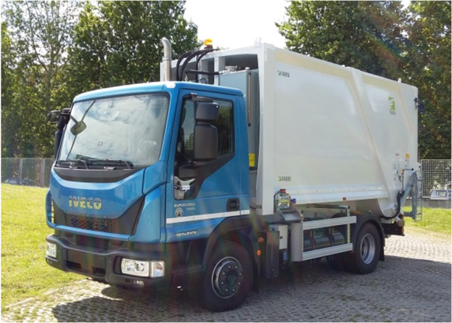 |  |  | The Eurocargo 120EL21 CNG is equipped with a fully automatic Allison 2500 transmission and the Farid PN10 Mini Compactor body
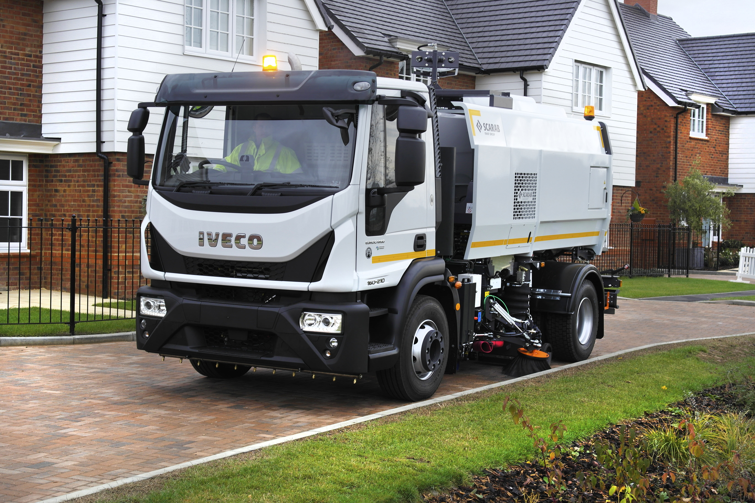 |  |  | The SCARAB MAJOR 5001 sweeper, built on a Eurocargo ML160E21 CNG chassis and equipped with a fully automatic Allison 3000 Series™ transmission, will be on display at Pollutec.
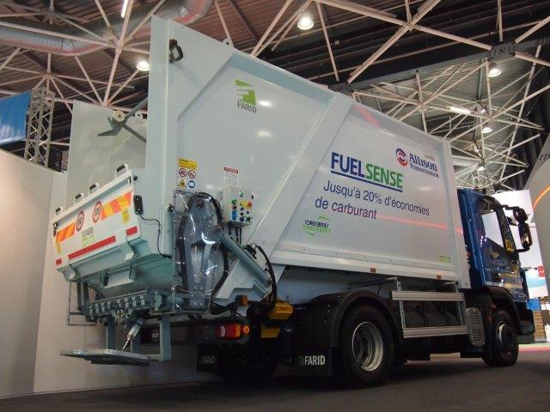 |  |  | A Farid PN10 Mini Compactor body optimized for organic waste collection and 480 litre/80 kg CNG tank are integrated with the truck.

