World's first Allison-equipped factory MAN truck begins service with Zell am Ziller volunteer fire brigade

First introduced at Interschutz 2015, the MAN TGS truck equipped with an Allison 4000 Series™ hits the road in Tyrol, Austria

ZELL AM ZILLER, Austria – Volunteer fire department Zell am Ziller recently took delivery of its newest fire truck, a MAN TGS 18.400 4x4 featuring an EMPL TLF-A 3000/150/50 body and a fully automatic Allison 4000 Series™ transmission.

"The MAN TGS 18.400 4x4 with an Allison transmission sets new standards for vehicles operating in heavy-duty fire and emergency applications,” said Roman Eggenfellner, team manager for municipal sales at MAN Truck & Bus Austria AG. “The assembly of the transmission ex-factory means on one hand the continuation of a long tradition and, on the other hand, satisfies the specific demands of the tender requirements in an impressive manner. The performance of this driveline in terms of acceleration and shift quality underlines MAN’s market and technology leadership in the fire and emergency market.”

Zell am Ziller is the heart of the Ziller Valley, a popular winter sports region in the Austrian Alps with 660,000 overnight stays per year. The operational area of the volunteer fire department covers 41 km² and includes a tunnel, three cable railway companies, numerous hotels, alpine meadows and ski huts, and an altitude difference of almost 2,000 meters.

"Dynamic uphill trips are very common for our rescue operations,” said Siegfried Geisler, commander of the Zell am Ziller fire brigade. “The starting and braking on steep gradients, narrow roads and hairpin curves requires full concentration of our drivers. We wanted an Allison Automatic because it provides the transmission technology we trust to get us to an emergency site faster and safer, even under harsh operating conditions."

Moving an 18-ton vehicle uphill quickly during emergency operation requires transferring full engine power and torque to the wheels. The Allison 4000 Series fully automatic transmission offers a patented torque converter and uninterrupted power shifts for excellent acceleration and continuous traction.

"By providing the Allison fully automatic available as series option, MAN Truck and Bus AG is fulfilling the desire of many fire departments for a drive configuration that offers outstanding performance, reliability and ease of use under extreme conditions” says Harald Rosenauer, director of OEM, DOEM and new business development in western and central Europe for Allison. “The MAN and Allison relationship provides a proven powertrain that perfectly fits the severe requirements of heavy duty rescue. With its 400 hp engine coupled with the Allison 4000 Series transmission, the vehicle delivers impressive acceleration and performance.”

Additionally, the integration of body and pumping equipment is crucial for the effectiveness of a fire truck. "EMPL is proud to present this vehicle together with MAN and Allison,” said Reinhard Gruber, fire trucks sales at EMPL. “With an Allison in the drive train, the chassis, body and pump work together efficiently. EMPL extinguishing technology makes the vehicle equipment optimum for any job.”

MAN TGS 18.400 4x4 BB, TLF-A 3000/150/50 with Allison 4000 transmission
and EMPL body

End user | Volunteer fire department Zell am Ziller, Austria
Chassis (manufacturer) | MAN Truck & Bus AG
Chassis (type) | MAN TGS 18.400 4x4 BB
Wheel base | 4.500 mm
Body (manufacturer) | EMPL
Body (type) | TLF-A 3000/150/50
Engine | MAN D20 CommonRail
Engine output | 294 kW (400 hp) / 1900 Nm
Transmission | Allison 4000 Series™ fully automatic transmission
Crew | 1+8
Extinguishing media | 3,000 liters of water, 150 liters of foam concentrate Class A, 50 liters of foam concentrate AFFF
Body specials | - H.I.T. CAN bus controller (display in the cab and at the pump)  - LED lighting concept  - 14 kVA power generator  - Pneumatic light mast Function Light, electric tilting and turning (8 x LED Headlamp)  - Foam proportioning: CTD Cameleon, electric foam pump - 30 l/min  - • Power-hose reel 50 m

About Allison Transmission
Allison Transmission (NYSE: ALSN) is the world’s largest manufacturer of fully automatic transmissions for medium- and heavy-duty commercial vehicles, and is a leader in hybrid-propulsion systems for city buses. Allison transmissions are used in a variety of applications including refuse, construction, fire, distribution, bus, motorhomes, defense and energy. Founded in 1915, the company is headquartered in Indianapolis, Indiana, USA and employs approximately 2,700 people worldwide. With a market presence in more than 80 countries, Allison has regional headquarters in the Netherlands, China and Brazil with manufacturing facilities in the U.S., Hungary and India. Allison also has approximately 1,400 independent distributor and dealer locations worldwide. For more information, visit allisontransmission.com.

About Empl Fahrzeugwerk Ges.m.b.H.
EMPL is one of the leading European manufacturers of individual special truck bodies. The Austrian bodybuilder EMPL is the contact for fire departments that require individual vehicle solutions tailored to their needs and desires. Based on a modular system, each vehicle is unique and developed specifically with and for the customer. Through close cooperation with the customer, it is possible to construct an operational optimized fire engine that meets the highest standards of quality, design, safety and functionality. Within the technical and legal framework, the customer can decide how the vehicle looks finally.

About Zell am Ziller fire brigade
The fire department Zell am Ziller celebrates its 150th anniversary this year; it was founded in 1866 and is the longest existing volunteer fire department in Tirol. It is also one of the 13 founding brigades of the State Fire Association Tyrol and member of the District Fire Brigade Association Schwaz. The Zell am Ziller volunteer fire department runs 130 to 180 operations per year, with 101 active members, 7 youth participants and 37 reservists. The operation area is 41 km² with around 3.500 inhabitants and includes a tunnel, three cable railway companies, several industrial companies and numerous hotels. Zell am Ziller is the heart of the Zillertal region, a popular winter sports destination with approx. 660,000 overnight stays annually. The Zillertal, located approximately 40 km east of Innsbruck, stretches from Strass im Zillertal to Mayrhofen where the valley divides into the Tux Valley, the Zemmgrund, the Stillupgrund and Zillergrund.

Contacts
Stefanie Vitt Miranda Jansen
geldermannKommunikation Allison Transmission
Agentur für Public Relations Marketing Communications
stefanie.vitt@geldermannkommunikation.de miranda.jansen@allisontransmission.com
+49 (0)2801-9 88 44 77 +31 (0)78-6422 174
Klever Straße 2 Baanhoek 188
46509 Xanten, Germany 3361 GN Sliedrecht, The Netherlands

Images (For editorial purposes only)

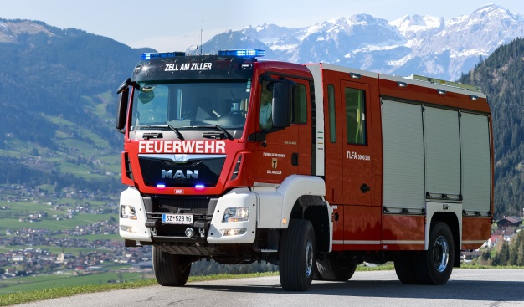  © Empl Fahrzeugwerk | The Zell am Ziller volunteer fire brigade recently took delivery of its newest fire truck, a MAN TGS 18.400 4x4 with an EMPL-body TLF-A 3000/150/50 and a fully automatic Allison transmission.
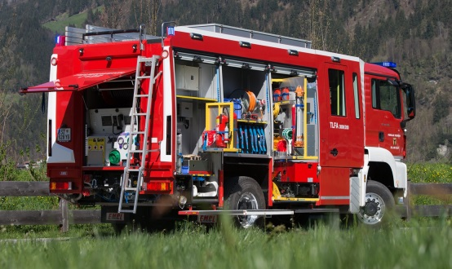  © Empl Fahrzeugwerk | MAN TGS 18.400 4x4 with Allison Transmission 4000 series and EMPL-body TLF-A 3000/150/50.
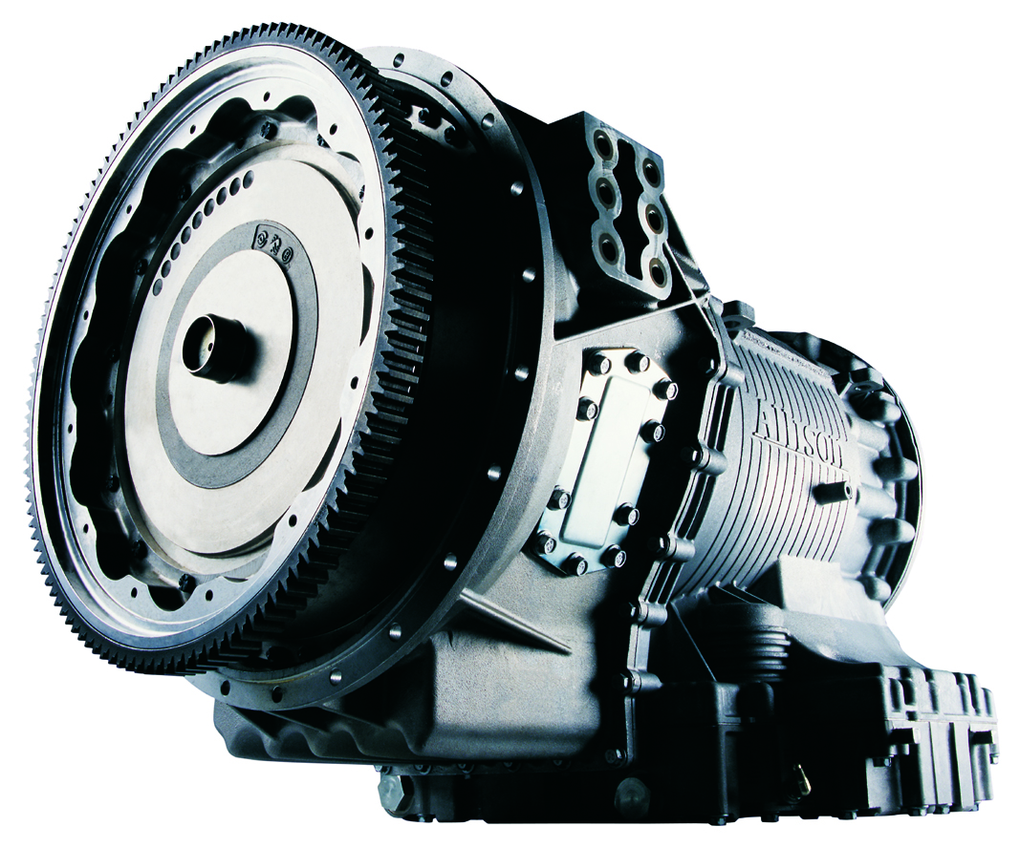  © Allison Transmission | Allison 4000 Series™ fully automatic transmission.
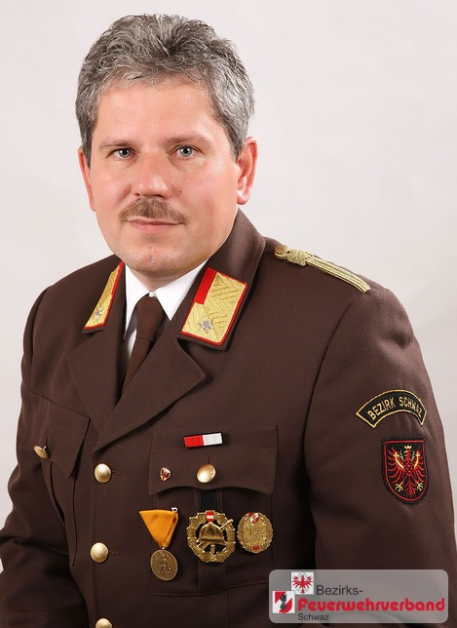  © Siegfried Geisler | “We wanted an Allison because it provides the transmission technology we trust to get us to an emergency site faster and safer, even under harsh operating conditions,"said Siegfried Geisler, commander of the Zell am Ziller fire brigade.
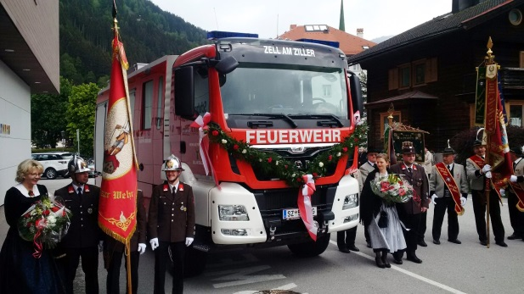  © Roman Eggenfellner, MAN Truck & Bus AG | Inauguration of the first MAN TGS vehicle at the voluntary fire brigade Zell am Ziller on the occasion of the “Florianifeier”, Pentecost 2016.
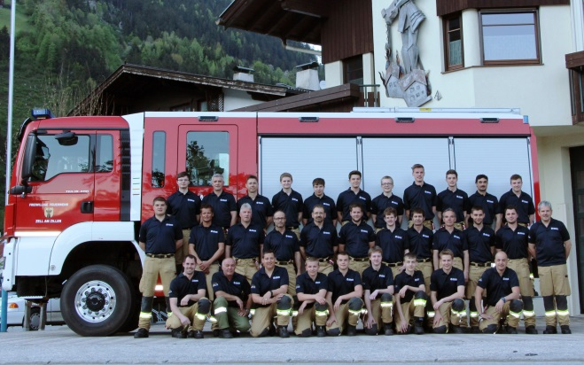  © Stefan Armellini, Feuerwehr Zell am Ziller | The voluntary fire brigade Zell am Ziller with Commander Siegfried Geisler (far right).
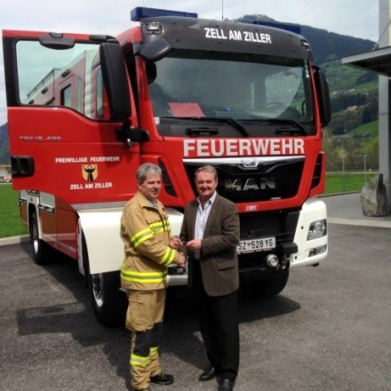  © Empl Fahrzeugwerk | Volunteer fire department Zell am Ziller takes delivery of the first MAN-TGS vehicle featuring an Allison 4000 Series™ fully automatic transmission.  Commander Siegfried Geisler and Managing Director Herbert Empl during the vehicle hand over.

