Allison Transmission demonstrates CNG/LNG power solutions
Leading European fleets experience the advantages of Allison fully automatic transmissions in alternative-fuel vehicles firsthand on the F1 Monza Circuit in Italy Sept. 25, 2015
TORINO, Italy – Allison Transmission dedicated Sept. 25, the first day of “Truck Emotion,” to a Ride & Drive at the F1 Monza Circuit to demonstrate the outstanding performance of natural gas vehicles (CNG and LNG) fitted with Allison fully automatic transmissions. Leading European OEMs discussed the advantages of Allison-equipped, alternative-fuel vehicles – from ease of use, comfort and safety to reduced fuel consumption and emissions.

European fleet representatives in the distribution and refuse industries attended the event. Presenters included Antonio Bravo, machinery department director at FCC Environment, a European leader in public waste and resource management, operating in 35 countries. In his presentation, “Application of Natural Gas in Urban Vehicles for Environmental Services,” Bravo shared FCC’s considerable experience with Allison-equipped CNG vehicles, noting they currently have over 1000 trucks in operation.

“At FCC, we first fitted an Allison transmission on one of our refuse trucks back in 1990,” said Bravo. “After realizing the economic advantages for a fleet as large as ours, we began using Allison Automatics in all of our refuse trucks. We strongly believe in this technology, and in the last few years, we also have been fitting Allison transmissions on our waste-bin washers, tankers and skip loaders,” he said.

According to Bravo, the economic, environmental and safety benefits Allison Transmission’s technology delivers are “crystal clear.” “Without a manual clutch, the maintenance costs decrease dramatically; Allison’s controlled acceleration reduces emissions and noise pollution; and safety increases together with driving comfort,” he said.
OEMs including Iveco, Renault, Volvo and Scania made Allison-equipped CNG vehicles available for the Ride & Drive following the workshop. CNG day guests were able to experience the benefits discussed during the morning’s workshop firsthand in a variety of vehicles, including a Scania G340 tractor on the Formula 1 Circuit.
In the afternoon, industry media joined the Ride & Drive and interviewed some of the participating fleet managers. Among Allison’s international guests, was the French group Fraikin, a European leader in industrial and commercial vehicle rental, with 175 branches in Europe and approximately 650M euro in annual sales volume. The company owns about 100 Allison transmissions fitted on medium- and heavy-duty trucks, according to Remi Paing, project manager at Fraikin.
“Our Allison-equipped vehicles operate in refuse and industrial waste collection, as well as refrigerated food transport. Advantages range from driving comfort and ease of maintenance in frequent stop-and-go duty cycles, to fuel savings, depending on the application,” said Paing. “We are particularly interested in the advantages derived from Allison transmissions matched with CNG engines. We think it is an engine technology with many relevant economic advantages and opportunities.”

Fraikin is not alone in taking this position. According to Clement Chandon, head of CNG/LNG sales development for Iveco Stralis in EMEA, “Iveco believes in and invests a lot in natural gas trucks. My job, created specifically for this market, is a testament to our will to make this technology known and appreciated,” he said.

“Natural gas markets are developing, above all in France. In the last 4 years, we have doubled sales of Iveco Stralis CNG and LNG trucks each year because there are large commercial chains and distribution companies looking for cleaner, quieter transport at lower costs than those of diesel engines,” said Chandon. “Now that end users and truck owners are starting to trust this technology, the market is poised to take off, and our dealer network is ready.”
Chandon pointed out that natural gas engines in heavy trucks are relatively small, compared to diesel models, which can raise valid concerns among fleet managers regarding startability and power. Since Allison has been supplying Iveco with fully automatic transmissions featuring Continuous Power Technology™ for the last 15 years, responsiveness in Allison-equipped alternative-fuel vehicles is not a concern at Iveco.
“Allison technology provides undeniable advantages for natural gas vehicles,” Chandon said. “Having a transmission that accelerates without ever losing power and a converter that multiplies torque at launch, highly improves fleet performance.”
About Allison Transmission
Allison Transmission (NYSE: ALSN) is the world’s largest manufacturer of fully automatic transmissions for medium- and heavy-duty commercial vehicles and is a leader in hybrid-propulsion systems for city buses. Allison transmissions are used in a variety of applications including refuse, construction, fire, distribution, bus, motorhomes, defense and energy. Founded in 1915, the company is headquartered in Indianapolis, Indiana, USA and employs approximately 2,700 people worldwide. With a market presence in more than 80 countries, Allison has regional headquarters in the Netherlands, China and Brazil with manufacturing facilities in the U.S., Hungary and India. Allison also has approximately 1,400 independent distributor and dealer locations worldwide. For more information, visit allisontransmission.com.
Press Contacts
Susanna Laino Miranda Jansen
Alarcón & Harris Allison Transmission Europe
susanna.laino@alarconyharris.com miranda.jansen@allisontransmission.com
+39 389-4746376 +31 78-6422 174
Avda. Ramón y Cajal, 27 Baanhoek 188
Madrid, Spain Sliedrecht, the Netherlands

Photographs
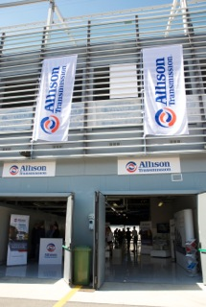 | Allison Transmission dedicated Sept. 25, the first day of “Truck Emotion,” to a Ride & Drive at the F1 Monza Circuit in Italy to demonstrate the outstanding performance of natural gas vehicles fitted with Allison fully automatic transmissions.
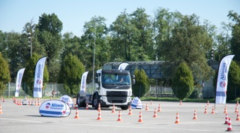 | In the afternoon, industry media joined CNG-day guests, who were able to experience the benefits discussed during the morning’s workshop firsthand in a variety of Allison-equipped vehicles at the F1 Monza Circuit’s paddock.
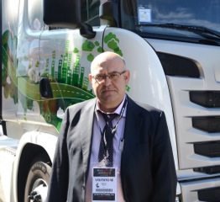 | Among Allison’s guests was Antonio Bravo, machinery department director at FCC Environment, a European leader in public waste and resource management, who shared FCC’s considerable experience with Allison-equipped CNG vehicles, noting they currently have over 1000 trucks in operation.
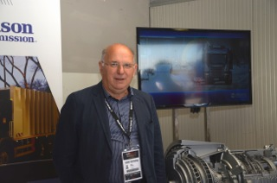 | “We are particularly interested in the advantages derived from Allison transmissions matched with CNG engines. We think it is an engine technology with many relevant economic advantages and opportunities,” said Remi Paing, project manager at Fraikin.
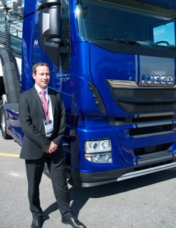 | “Allison technology provides undeniable advantages for natural gas vehicles,” said Clement Chandon, head of CNG/LNG sales development for Iveco Stralis in EMEA. “Having a transmission that accelerates without ever losing power and a converter that multiplies torque at launch, highly improves fleet performance.”
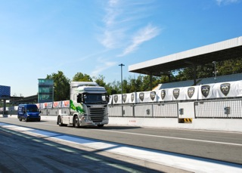 | An Allison-equipped Scania G340 on the Formula 1 Circuit in Monza, Italy.
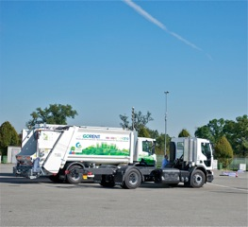 | Among the vehicles available for the CNG-Day Ride & Drive, were an Iveco Stralis, a Renault D-Wide, and Volvo FE and Scania G340 trucks, all with natural gas engines and Allison fully automatic transmissions.
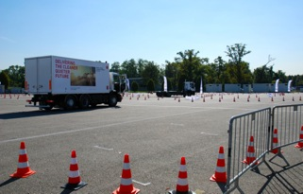 | An Allison-equipped Renault D-Wide on the test track in Monza, Italy.

