Increased productivity, reduced noise leads Trío Operadores to add Allison-equipped Econic NGT distribution vehicles
News Release
Trío Operadores Logísticos now has three Mercedes Econic NGT vehicles fitted with Allison fully automatic transmissions, increasing both fleet productivity and driver satisfaction in Madrid and Zaragoza
MADRID – Since June 2014, a new Mercedes Econic NGT (Natural Gas Technology) fitted with an Allison 3000 Series™ fully automatic transmission has been operating in Madrid. The Trio Operadores Logísticos S.L. fleet vehicle delivers goods nightly to supply Simply Market supermarkets, one of the operator’s most important customers.
The Clean Truck Project (Proyecto Camión Limpio), which began in May 2012, was the result of a cooperative arrangement between Simply Market, Mercedes Benz and Trío Operadores Logísticos. The goal was to make the unloading of goods more eco-friendly, improving the efficiency of the fleet to the extent of reducing the number of vehicles operating, while maintaining productivity and profitability. To achieve sustainable urban distribution – less noise, less traffic and reduced CO₂ emissions, a first compressed natural gas (CNG) truck, a Mercedes Econic NGT, went into service delivering to Simply Markets in Madrid. The introduction of this first vehicle allowed Trío Operadores Logísticos to take three older trucks out of service.
Subsequently, a Mercedes Antos Euro 6 has been added to the fleet in Madrid and a gas-powered Econic was added to the fleet in service in Zaragoza. In the third phase of the project, the company purchased another Econic NGT for the Spanish capital, at the same time relieving four older trucks of duty.
According to Javier Hernández de Vicente, director of Trío Operadores Logísticos, the highly successful experience with the first Econic led to the addition of this latest truck:
“In the first stage of this project, we achieved a 33 percent reduction in urban delivery emissions for the city of Madrid. With the addition of the second Econic NGT truck in the capital, which will also operate at night, our aim is to achieve a reduction of 60 percent as compared to initial emissions figure when the project began,” Hernández said.
Trío Operadores has a fleet of 150 rigid, refrigerated and general cargo vehicles, of which 25 are proprietary and the others are leased on a fixed-contract basis. The introduction of the Mercedes NGT models enabled the company to reduce its proprietary truck fleet from 18 to 11 due to the Econic’s increased load capacity of 27 pallets. This enabled Simply to optimize the number of delivery trips to its supermarkets.
The demand for fully automatic transmissions with torque converters in the urban distribution sector continues to grow because they deliver significant productivity and performance advantages over manual and automated manual transmissions, especially in combination with natural gas engines.
“After two years, the experience with these transmissions has been extraordinary, above all with respect to engine torque. The torque converter enhances gas engines’ torque at launch and provides drivers with comfortable handling,” added Hernández.
Allison Automatics are the only transmission option in the Econic NGT, as it perfectly suits the vehicle’s driveline. Allison’s Continuous Power Technology™ ensures smooth, uninterrupted power transfer to the drive wheels, as well as superior vehicle launch due to multiplication of engine torque at low RPMs. Moreover, a key objective of trucks equipped with natural gas engines is to reduce noise – by three to six decibels as compared to equivalent diesel trucks – and the helical gear design of Allison automatic transmission helps to achieve this goal.
The new Econic also features the Transgiro axle system, which enables a very small turning radius to facilitate maneuverability and precision in the typically tight spaces created in dense cities. In combination with the Allison Automatic, vehicle control and maneuverability on roundabouts, corners, bends, loading and unloading ramps and other urban fixtures are further enhanced. During maneuvering, the Allison torque converter allows for precise inching control and smooth, low-speed motion. As clutch wear is no longer a problem, vehicle maintenance is greatly reduced resulting in reduced ownership costs.
“Our reasons for once again choosing the Allison-equipped Econics are efficiency, driver comfort, silent operation and reliability.” For Director Hernández, the benefits of an Allison are very clear. “You don’t even have to think about the transmission, you just accelerate and move forward,” he said.
About Allison Transmission
Allison Transmission (NYSE: ALSN) is the world’s largest manufacturer of fully automatic transmissions for medium- and heavy-duty commercial vehicles, and is a leader in hybrid-propulsion systems for city buses. Allison transmissions are used in a variety of applications including refuse, construction, fire, distribution, bus, motorhomes, defense and energy. Founded in 1915, the company is headquartered in Indianapolis, Indiana, USA and employs approximately 2,700 people worldwide. With a market presence in more than 80 countries, Allison has regional headquarters in the Netherlands, China and Brazil with manufacturing facilities in the U.S., Hungary and India. Allison also has approximately 1,400 independent distributor and dealer locations worldwide. For more information, visit allisontransmission.com.

About Trio Operadores Logísticos
Trío Operadores Logísticos is a logistics operator that offers a wide range of transport solutions and services. The company has facilities in Madrid, Valencia, Alicante and Zaragoza. It boasts a specialized fleet for refrigerated transport and delivers to food markets by pre-established routes, as well as offering urgent door-to-door services, national and international deliveries, large-volume deliveries and capillary distribution. For more information, visit http://trioperadores.com/.
Press contacts:
Nuria Martí  Alarcón & Harris  Asesores de Comunicación y Marketing  nmarti@alarconyharris.com  +34 91 415 30 20  Avda. Ramón y Cajal, 27  28016 Madrid | Miranda Jansen  Allison Transmission Europe B.V.  Marketing Communications  miranda.jansen@allisontransmission.com  +31 (0)78 6422174  Baanhoek 188  3361GN Sliedrecht (Países Bajos)

Photographs
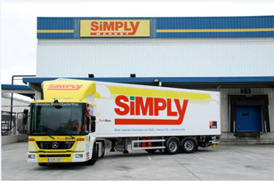  © Trio Operadores | The Clean Truck Project (Proyecto Camión Limpio), the result of a cooperative arrangement between Simply, Mercedes Benz and Trío Operadores Logísticos to make the unloading of goods more eco-friendly, while maintaining efficiency, productivity and profitability.
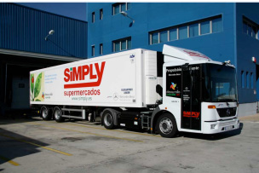  © Trio Operadores | The Mercedes Econic NGT, went into service delivering to Simply Supermarkets in Madrid.
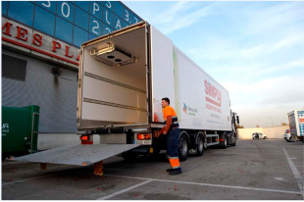  © Allison Transmission | Allison Automatics are the only transmission option in the Econic NGT, as it perfectly suits the vehicle’s driveline, ensuring smooth, uninterrupted power transfer to the drive wheels, as well as superior vehicle launch due to multiplication of engine torque at low RPMs.
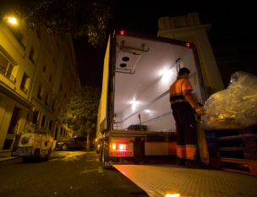  © Allison Transmission | The helical gear design of Allison fully automatic transmissions significantly contributes to noise reduction.
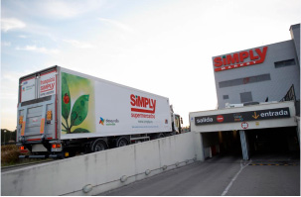  © Allison Transmission | The new Econic also features the Transgiro axle system, which combined with the Allison transmission, facilitates maneuverability and precision in large, dense cities.
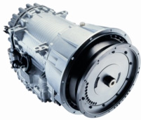  © Allison Transmission | The Mercedes Econic NGT features an Allison 3000 Series™ fully automatic transmission with integral retarder.

